PRIMARY 4 FRENCH LANGUAGE SCHEME OF WORK

FIRST TERM

Week | Topic | Breakdown (Subtopics)
1 | Pourquoi apprendre le français? (Why learn French?) | - Importance of learning French: international language, career opportunities  - French-speaking countries in Africa: Senegal, Côte d'Ivoire, Benin, Togo, Niger, Mali, etc.  - French in Nigeria: neighboring countries, international relations, education  - Basic French greetings: Bonjour, Bonsoir, Salut  - Introduction to French alphabet and pronunciation  - Motivating students: French songs, cartoons,  famous French speakers
2 | Saluer (Greetings) - Part 1 | - Formal greetings: Bonjour (Good morning/day), Bonsoir (Good evening), Bonne nuit (Good night)  - Informal greetings: Salut (Hi), Coucou (Hey)  - Asking "How are you?": Comment allez-vous? (formal), Comment ça va? (informal)  - Responses: Ça va bien (I'm fine), Très bien (Very well), Comme ci comme ça (So-so)  - Practice dialogues with greetings
3 | Saluer (Greetings) - Part 2 | - Saying goodbye: Au revoir (Goodbye), À bientôt (See you soon), À demain (See you tomorrow)  - Polite expressions: S'il vous plaît (Please),  Merci (Thank you), De rien (You're welcome),
Excusez-moi (Excuse me), Pardon (Sorry)
- Role-playing greetings in different situations
- Greeting songs and rhymes
- Cultural note: French greeting customs (handshakes, "la bise")
4 | Se présenter (Introducing Oneself) - Part 1 | - Saying your name: Je m'appelle... (My name is...), Je suis... (I am...)  - Asking someone's name: Comment tu t'appelles? (What's your name? - informal), Comment vous appelez-vous? (formal)  - Stating nationality: Je suis nigérian(e) (I am Nigerian)  - Basic personal pronouns: Je (I), Tu (You - informal), Vous (You - formal), Il (He), Elle (She)  - Practice introducing yourself and asking others'  names
5 | MID-TERM  EXAMINATION | - Assessment of Weeks 1-4 (Oral and Written)
6 | MID-TERM BREAK | - Holiday/Rest
7 | Se présenter (Introducing Oneself) - Part 2 | - Stating age: J'ai ... ans (I am ... years old), Quel âge as-tu? (How old are you?)  - Numbers 1-20 in French (for age): un, deux, trois, quatre, cinq, six, sept, huit, neuf, dix, onze, douze, treize, quatorze, quinze, seize, dix-sept, dix-huit, dix-neuf, vingt  - Gender: Je suis un garçon (I am a boy), Je suis une fille (I am a girl)  - Practice complete self-introductions  - Listening exercises with introductions

8 | Prendre congé (Taking Leave)  - Part 1 | - Various ways to say goodbye: Au revoir, Adieu (Farewell), Salut (Bye - informal)  - Time-specific farewells: À tout à l'heure (See you later - today), À ce soir (See you tonight), À la prochaine (Until next time)  - Wishing well: Bonne journée (Have a good day), Bon week-end (Have a good weekend), Bonnes vacances (Have a good holiday)  - Appropriate farewells for different times and  situations
9 | Prendre congé (Taking Leave)  - Part 2 | - Expressing gratitude when leaving: Merci beaucoup (Thank you very much), Merci pour tout (Thank you for everything)  - Combined greetings and farewells in dialogues  - Cultural differences in taking leave (French vs. Nigerian customs)  - Role-play: complete conversations from greeting to farewell  - Creating dialogues in pairs and groups
10 | Review and Integration: Identity Theme | - Comprehensive review of all identity/identification topics  - Creating personal identity cards in French (name, age, nationality)  - Class presentations: students introduce themselves completely  - Group dialogues: meeting, greeting, introducing, saying goodbye  - French pronunciation practice and correction  - French language games: "Je m'appelle" game, greeting relay

11 | REVISION | - Review: Greetings, introductions, farewells,  numbers 1-20, basic expressions
12 | EXAMINATION | - End of Term Assessment (Oral and Written)
13 | CLOSING/VACATION | - Term ends

PRIMARY 4 FRENCH LANGUAGE LESSON NOTES FIRST TERM
WEEK 1: POURQUOI APPRENDRE LE FRANÇAIS? (WHY LEARN FRENCH?).

OBJECTIVES By the end of the lesson, pupils should be able to:

- State two reasons why learning French is important.
- List three French-speaking countries in Africa (Francophone countries).
- Identify Nigeria's neighbors that speak French.
- Recite the first 5 letters of the French alphabet.

CONTENT Importance of Learning French: French is not just another subject; it is a key that opens many doors. It is an international language, which means it is spoken by millions of people in many countries around the world, not just in France.
Learning French helps us in our daily lives and future:

- To Communicate: Nigeria shares borders with countries where French is the main language. If you learn French, you can talk to your neighbors, make new friends, and understand them when you visit their markets or towns.
- For Better Opportunities: When you grow up, knowing French can help you get interesting jobs. You could work as a translator (helping people understand each other), in tourism (guiding French visitors around Nigeria), or even for big international organizations.
- For Education and Travel: Many interesting books, cartoons (like Asterix), websites, and news reports are in French. Learning it lets you enjoy them. Also, if you travel to countries like Benin or Niger, you can ask for directions, buy things, and feel more confident.
French in Nigeria and Africa (Francophone Africa): A Francophone country is a country where French is widely spoken. In Africa, there are many!
Nigeria's French-Speaking Neighbors: Look at a map. Nigeria is like a big house with neighbours who speak French. These neighbours are:
- Bénin (Benin Republic) - to the West
- Niger - to the North
- Tchad (Chad) - to the North-East
- Cameroun (Cameroon) - to the East

Other Major Francophone African Countries: French is spoken in many countries across West and Central Africa. Some big ones are:
- Sénégal (Senegal)
- Côte d'Ivoire (Ivory Coast)
- Mali
- Togo
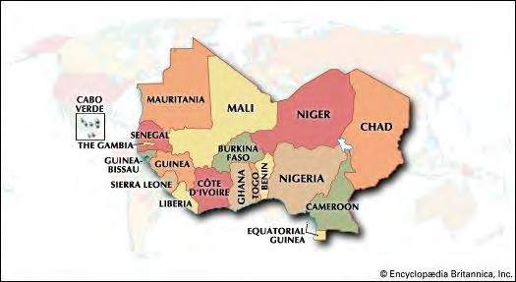

Basic French Alphabet (Introduction): The French alphabet has 26 letters, just like English, but the sounds are often different. It's like learning a new song for familiar letters. Let's start with the first five. We pronounce them clearly and slowly.
- A (ah) - Sounds like the "a" in "father".
- B (bay) - Sounds like "bay" without the 'y' sound at the end.
- C (say) - Sounds like the English word "say".
- D (day) - Sounds like the English word "day".
- E (uh) - Sounds like a short "uh" sound, like the 'e' in "the".

Tip: Your mouth shape is very important in French. For 'E' (uh), keep your lips relaxed and your jaw slightly open.
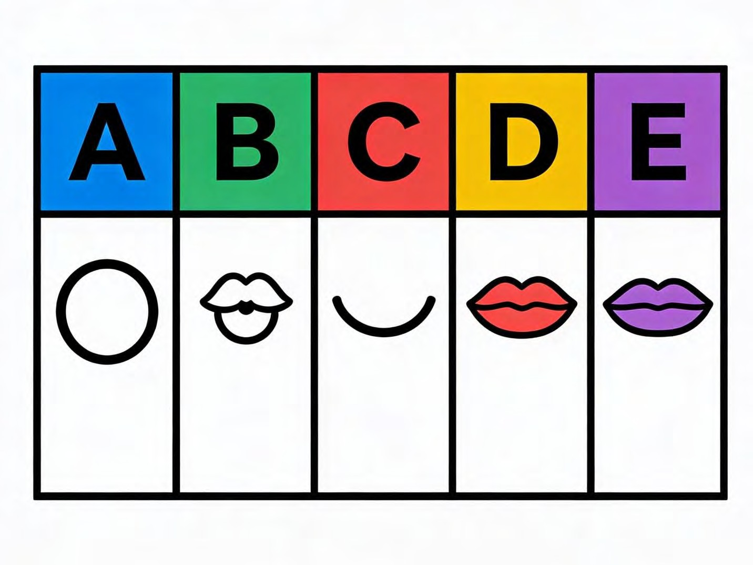

Motivation and Fun: Learning French is an adventure! You can start by learning simple songs ("Frère Jacques" is a popular one), watching educational cartoons, or learning how to say the names of your favourite Nigerian foods in French. Every new word you learn is a step towards becoming a language expert!
EVALUATION

- Give one reason why learning French is useful for someone living in a border town in Nigeria. (To communicate and trade with neighbours).
- Name two countries that share a border with Nigeria where people speak French.
- Look at the map of Africa. Can you name one Francophone country that is NOT Nigeria's neighbour? (e.g., Senegal, Ivory Coast, Mali).
- Pronounce the French letter C for the class. (Say).
- Is the sound of the French letter E similar to the English letter 'E' in "egg"? (No, it sounds like "uh").
ASSIGNMENT

- (Drawing & Writing): Draw a simple outline map of Nigeria.

- On the side where Benin is located, draw a small flag and write "Bénin".

- On the side where Niger is, draw another flag and write "Niger".

- (Oral/Written): Practice saying the first five French letters aloud. Then, write them down with their pronunciation next to them (e.g., A - ah).
- (Oral Research): Ask an older sibling, parent, or guardian: "Do you know any French word?" Write down one word they tell you and find out what it means.

WEEK 2: SALUER (GREETINGS) - PART 1.

OBJECTIVES By the end of the lesson, pupils should be able to:

- Differentiate between formal and informal greetings.
- Say "Good Morning" and "Good Evening" in French.
- Ask "How are you?" in French.
- State three appropriate responses to "How are you?".

CONTENT Formal vs. Informal Greetings: Knowing the Difference: Knowing who you are talking to is very important in French, just like in Nigerian culture. We use different greetings to show respect.
Formal Greetings (Politesse): We use these with people we respect, people older than us, or people we don't know very well. Examples: your teacher, your principal, your friend's parents, a market stall owner.
- Bonjour (bohn-zhoor): This means "Good day" or "Hello". It is the most common and polite greeting. You use it from the time you wake up until around 6:00 PM.
- Bonsoir (bohn-swahr): This means "Good evening". You use it from around 6:00 PM
until you go to bed.
- Bonne nuit (bun nwee): This means "Good night". You only use this when someone is going to sleep. It is not an evening greeting.
Informal Greetings (Amiable): We use these with people of the same age, close friends, or family members (like siblings).
- Salut (sah-loo): This is a casual "Hi" or "Bye". It's friendly and relaxed.
- Coucou (koo-koo): This is a very playful, informal "hello," like "peekaboo" or "hey there!" often used with close friends or young children.
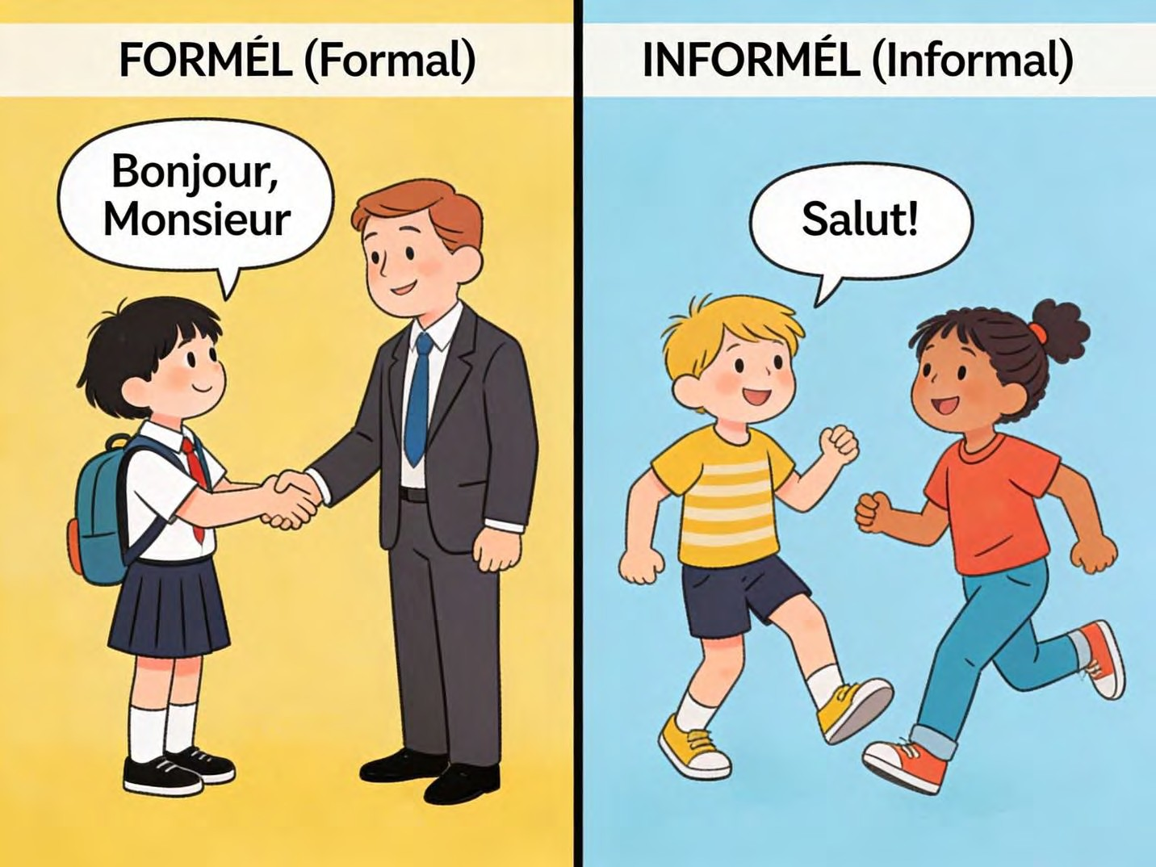
Asking "How Are You?" (Comment ça va?): After saying "Bonjour" or "Salut", it is polite to ask about the person's well-being.
- Formal Question: Comment allez-vous? (koh-mohn tah-lay voo). This is the respectful way to ask an adult or someone important.
- Informal Question: Comment ça va? (koh-mohn sah vah) or simply Ça va? (sah vah). This is what you use with friends and classmates.
How to Respond (Les Réponses): When someone asks you "Ça va?", you can reply in many ways:
- Ça va bien. (sah vah byehn) - I am fine.
- Très bien. (treh byehn) - Very well.
- Comme ci, comme ça. (kohm see, kohm sah) - So-so. (You say this while making a flat, side-to-side hand gesture).
- Oui, ça va. Merci. (Wee, sah vah. Mair-see) - Yes, I'm okay. Thank you.

It is always polite to say "Merci" (Thank you) after responding, and you can also ask back: "Et toi?" (And you?) to your friend or "Et vous?" to an adult.
EVALUATION

- You meet your headteacher at the school gate at 8 AM. What is the correct French greeting to use? (Bonjour).
- Your friend Amina comes to play at 4 PM. What casual greeting can you use? (Salut).
- What does "Bonsoir" mean and when do you use it? (Good evening, used after 6 PM).
- How would you ask your classmate, Chinedu, "How are you?" in French? (Comment ça va? / Ça va?).
- How do you say "Very well" in French? (Très bien).
- When is it correct to say "Bonne nuit"? (Only when someone is going to bed to sleep).

ASSIGNMENT

- (Written): What French greeting would you use at these times? Write your answer.

- a) 10:00 in the morning (meeting a neighbour):

- b) 7:00 in the evening (seeing your uncle):

- (Role-play/Oral): With a partner at home, practice a greeting. One person says "Bonjour" or "Salut", the other asks "Ça va?", and the first person replies "Ça va bien, merci. Et toi?".
- (Written): Write the French phrase for "I am fine, thank you."

WEEK 3: SALUER (GREETINGS) - PART 2.

OBJECTIVES By the end of the lesson, pupils should be able to:

- Mention three ways to say goodbye in French.
- Identify "Magic Words" (polite expressions) in French.
- Perform a simple greeting role-play.
- Describe the French custom of "la bise."

CONTENT Saying Goodbye (Les Au Revoir): Just like greetings, there are different ways to say goodbye depending on when you will see the person again.
- Au revoir (oh ruh-vwahr): This is the standard, polite "Goodbye". You can use it in most situations, formal or informal.
- À bientôt (ah byehn-toh): This means "See you soon". Use it when you expect to see the person again in a few days or weeks.
- À demain (ah duh-mahn): This means "See you tomorrow". Perfect for your classmates at the end of the school day.
The "Magic Words" (Les Mots Magiques): These are short, powerful words that make you sound polite and respectful. They are like magic because they make people happy to help you!
- S'il vous plaît (seel voo pleh) - Please (formal).
- S'il te plaît (seel tuh pleh) - Please (informal, to a friend).
- Merci (mair-see) - Thank you.
- De rien (duh ryehn) - You're welcome (Literally "It's nothing").
- Excusez-moi (ex-koo-zay mwah) - Excuse me (to get attention politely).
- Pardon (pahr-dohn) - Sorry (for a small bump) or Excuse me (to get past someone).
- Désolé(e) (day-zoh-lay) - Sorry (for a mistake. Add 'e' if you are a girl: Désolée).

A Simple Greeting Role-Play: Let's put it all together in a short conversation between two friends, Kofi and Aisha.
- Kofi: Salut, Aisha! (Hi, Aisha!)
- Aisha: Salut, Kofi! Ça va? (Hi, Kofi! How are you?)
- Kofi: Ça va bien, merci. Et toi? (I'm fine, thank you. And you?)
- Aisha: Très bien! Au revoir! (Very well! Goodbye!)
- Kofi: À demain! (See you tomorrow!)

Cultural Note: Greetings in France (La Bise): In France and some other French-speaking countries, friends and family often greet each other with "la bise" (lah beez). This is not a kiss on the lips. It is a light touch of the cheeks while making a soft kissing sound in the air. They usually do it twice (left cheek, then right cheek). It's a sign of friendship.
In Nigeria: We don't typically do la bise. We shake hands, wave, or give a respectful nod. It's important to know about other cultures, but in your French class, a smile and a "Bonjour" are perfect!
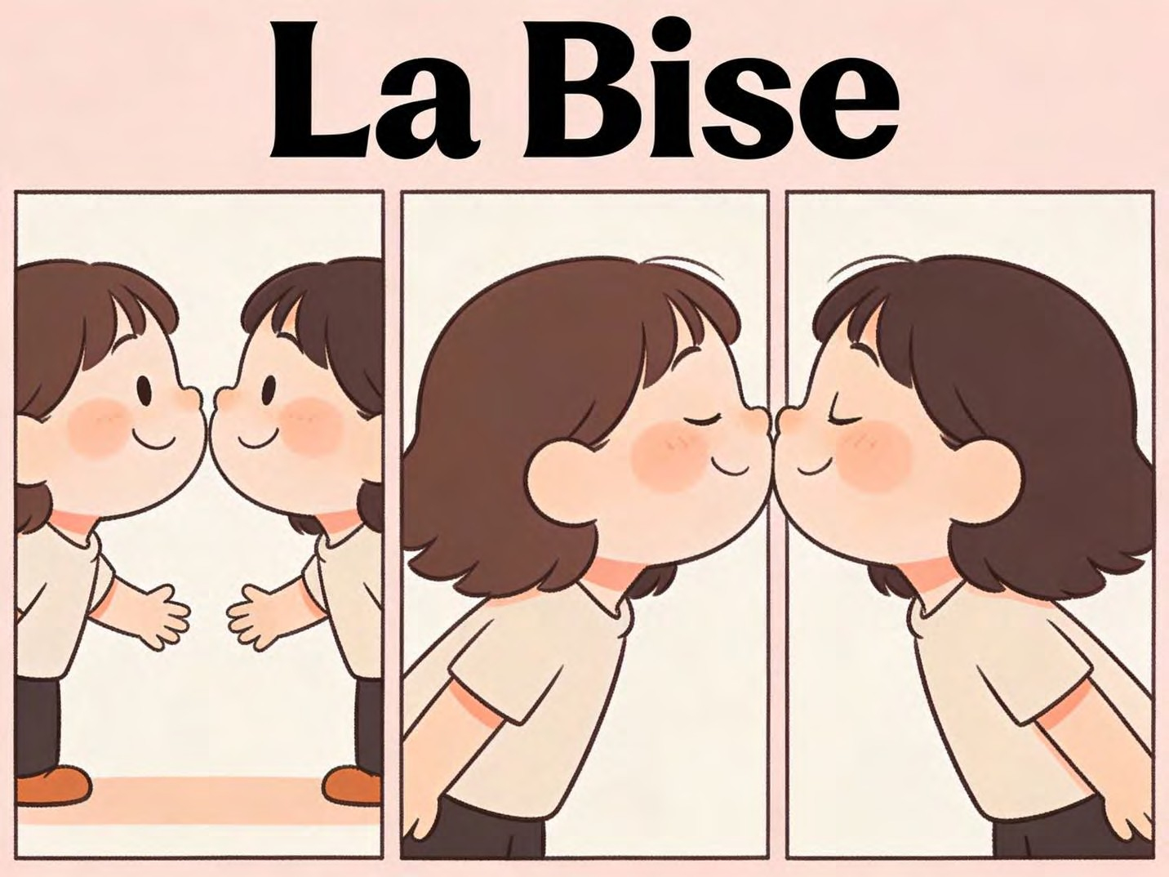

EVALUATION
- What is the most common French word for "Goodbye"? (Au revoir).
- You will see your friend in class tomorrow. What can you say instead of "Au revoir"? (À demain).
- What is the "magic word" you say when you ask for a pencil? (S'il te plaît / S'il vous plaît).
- What does "Merci" mean? (Thank you).
- What is "la bise"? (A French custom of greeting by touching cheeks).
- If you step on someone's foot, which word do you say? (Pardon or Désolé(e)).

ASSIGNMENT

- (Matching): Draw lines to match the French word to its English meaning:

- Merci -> Thank you

- Pardon -> Sorry / Excuse me

- Au revoir -> Goodbye

- S'il vous plaît -> Please

- (Written): Write the French phrase you would use when you want to ask your teacher for help politely. ( , Madame/Monsieur).
- (Drawing Practical): Draw two simple stick-figure friends waving to each other. In a speech bubble, write the French word for "Goodbye".

WEEK 4: SE PRÉSENTER (INTRODUCING ONESELF) - PART 1.

OBJECTIVES By the end of the lesson, pupils should be able to:

- Introduce themselves by stating their names in French.
- Ask someone for their name.
- State their nationality in French.
- List the basic personal pronouns (I, You, He, She).

CONTENT Saying Your Name (Je m'appelle...): The most important thing to tell someone is your name! In French, there are two main ways:
- Je m'appelle... (zhuh mah-pell...): This literally means "I call myself...". It is the most common and natural way to say "My name is..."
- Example: Je m'appelle Chiamaka. (My name is Chiamaka.)

- Je suis... (zhuh swee...): This means "I am...". It is also correct but is a bit more direct.

- Example: Je suis Ahmed. (I am Ahmed.)

Asking Someone's Name: To make a new friend, you need to ask their name. Remember the difference between formal ("vous") and informal ("tu").
- Informal (to a classmate or child): Comment tu t'appelles? (koh-mohn too tah-pell?) - What is your name?
- Formal (to a teacher or adult): Comment vous appelez-vous? (koh-mohn voo zah-play voo?) - What is your name?
Stating Your Nationality (Être Nigérian(e)): To say where you are from, we use "Je suis" (I am) + your nationality. In French, the nationality word changes for boys and girls.
- I am Nigerian (a boy says): Je suis Nigérian. (zhuh swee Nee-jay-ree-ahn)
- I am Nigerian (a girl says): Je suis Nigériane. (zhuh swee Nee-jay-ree-ahn) Notice the extra 'e' at the end for a girl.
This rule is common: for many nationalities, we add an 'e' for the feminine form.
Basic Personal Pronouns (Les Pronoms Personnels): Pronouns are small words we use instead of repeating a name. They are the subject of a sentence (who is doing the action).
- Je (zhuh) - I
- Tu (too) - You (informal, singular)
- Il (eel) - He
- Elle (ell) - She

Important: Vous (voo) can mean "You" (formal, to one person) OR "You" (plural, to a group).
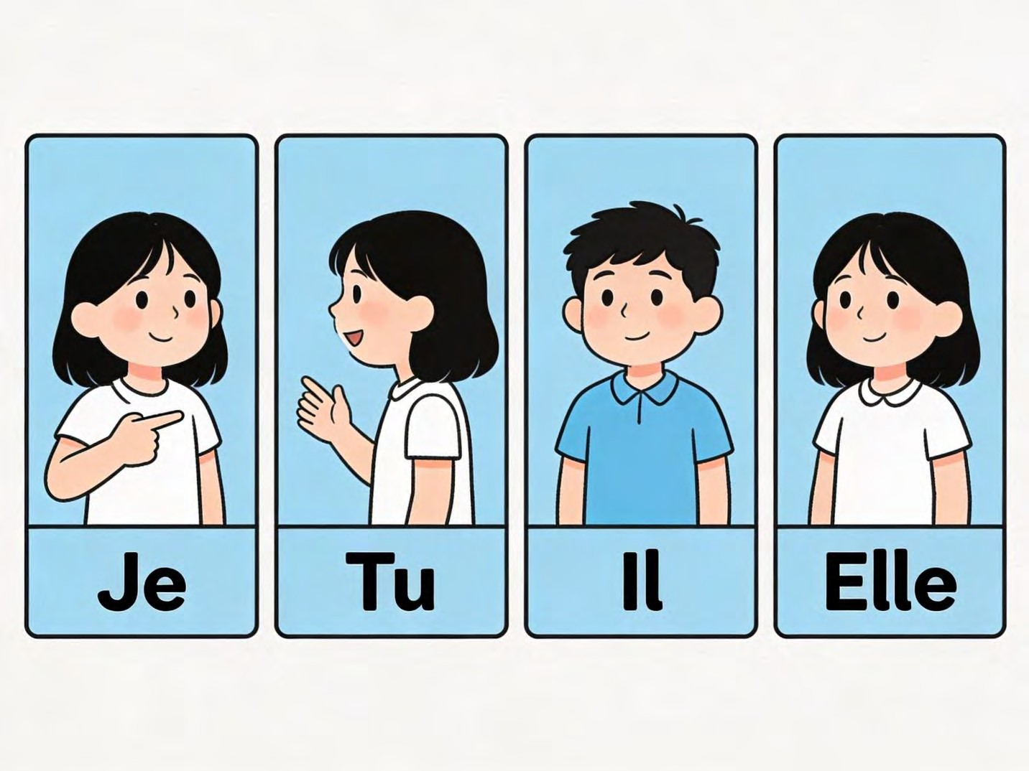

EVALUATION

- How do you say "My name is Bola" in French? (Je m'appelle Bola).
- You meet a new student in your class. How do you ask for their name? (Comment tu t'appelles?).
- If you are a girl, how do you say "I am Nigerian" in French? (Je suis Nigériane).
- What is the French pronoun for "He"? (Il).
- What is the French pronoun for "She"? (Elle).
- Complete this sentence in French: " m'appelle Tunde." (Je).

ASSIGNMENT

- (Written): Write a sentence introducing yourself with your name. (Je m'appelle
.)
- (Written): Write a sentence stating your nationality. Remember to check if you are a boy (Nigérian) or a girl (Nigériane).
- (Listing): Write down the four French subject pronouns and their English meanings: Je (I), Tu (You), Il (He), Elle (She).

WEEK 5: MID-TERM EXAMINATION (Assessment of topics covered in Weeks 1-4).

WEEK 6: MID-TERM BREAK (Holiday/Rest Period).

WEEK 7: SE PRÉSENTER (INTRODUCING ONESELF) - PART 2.

OBJECTIVES By the end of the lesson, pupils should be able to:

- Count from 1 to 20 in French.
- State their age in French.
- Ask someone "How old are you?".
- Identify their gender (Boy or Girl) in French.

CONTENT Numbers 1-20 (Les Nombres de 1 à 20): Numbers are very useful! We need them for age, counting, and later for telling time. Let's learn them with a rhythm or a song to make it easier.
- 1-10: Un (uh), Deux (duh), Trois (twah), Quatre (kat-ruh), Cinq (sank), Six (sees), Sept (set), Huit (weet), Neuf (nuhf), Dix (dees).
- 11-15: Onze (onz), Douze (dooz), Treize (trez), Quatorze (kah-torz), Quinze (kanz).
- 16-20: Seize (sez), Dix-sept (dee-set), Dix-huit (dee-zweet), Dix-neuf (dee-nuhf), Vingt (van).
Pronunciation Tip: For 17, 18, 19, think "Ten-seven", "Ten-eight", "Ten-nine". The 'x' in dix
becomes a 'z' sound before sept and huit.
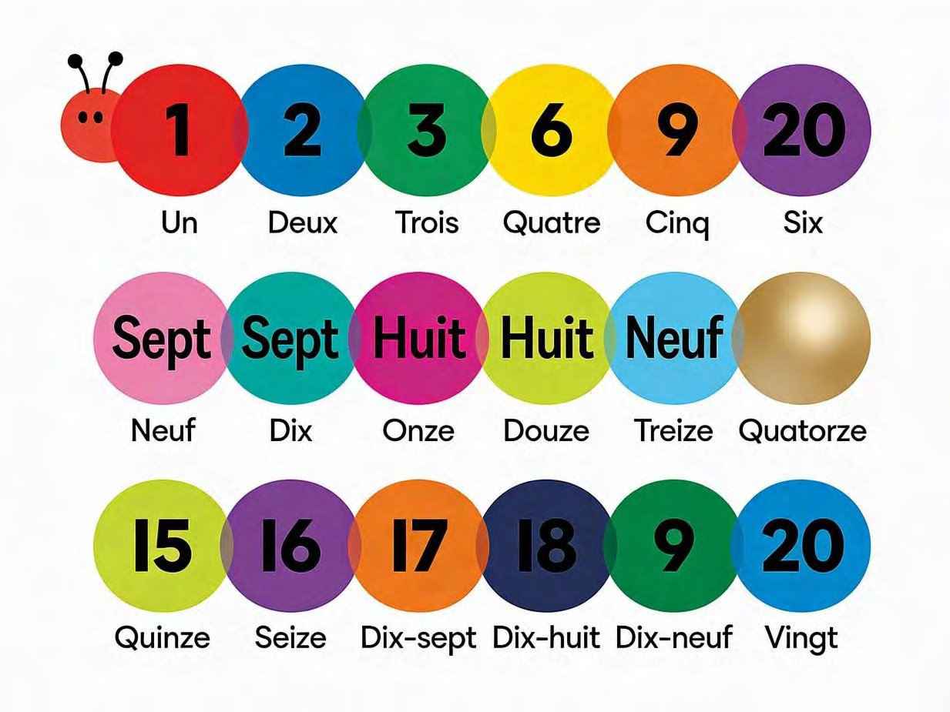

Stating Your Age (Quel âge as-tu?): In English, we say "I am 9 years old." In French, we use the verb "avoir" (to have). We say "I have 9 years."
- Question (Informal): Quel âge as-tu? (kel ahzh ah too?) - How old are you?

- Answer: J'ai ans. (zhay ahn) - I am years old.

- Example: J'ai neuf ans. (I am 9 years old.)

- Example: J'ai dix ans. (I am 10 years old.)

- J'ai is the contraction of Je + ai (I have).

Stating Your Gender: This is a simple but important part of introducing yourself.

- I am a boy: Je suis un garçon. (zhuh swee uhn gar-sohn)
- I am a girl: Je suis une fille. (zhuh swee oon fee-yuh)

Note: "Un" is used for masculine words (garçon), "une" for feminine words (fille).
EVALUATION

- Count from un to cinq (1 to 5) in French.
- What is the French word for the number 10? (Dix).
- Translate this sentence: "J'ai huit ans." (I am eight years old).
- How does a boy say "I am a boy" in French? (Je suis un garçon).
- How does a girl say "I am a girl" in French? (Je suis une fille).
- Spell the number 4 using French letters. (Q-U-A-T-R-E).

ASSIGNMENT

- (Written): Write the following numbers in French words: 5 (cinq), 12 (douze), 20 (vingt).
- (Written): Write a complete sentence in French stating how old you are. (J'ai ans.)
- (Translation): Translate this sentence into English: "Je suis une fille." (I am a girl).

WEEK 8: PRENDRE CONGÉ (TAKING LEAVE) - PART 1.

OBJECTIVES By the end of the lesson, pupils should be able to:

- List three different ways to say goodbye based on time.
- Use expressions to wish someone well.
- Match the correct farewell to the situation.

CONTENT More Ways to Say Goodbye: We already know "Au revoir". But French has special phrases for different situations, just like we might say "Safe journey!" in English.
- Adieu (ah-dyuh): This is a very formal and final "Farewell". It implies you might not see the person for a very long time or ever again. Use it rarely.
- Salut (sah-loo): Remember, this friendly word means both "Hi" and "Bye" when talking to friends.
Time-Specific Goodbyes: These are useful because they tell the person when you expect to see them next.
- À tout à l'heure! (ah toot ah luhr) - See you later! (Used when you will see the person again later the same day, like after break time).
- À ce soir! (ah suh swahr) - See you tonight! (If you have plans to meet in the evening).
- À la prochaine! (ah lah proh-shen) - Until next time! (A friendly, general phrase for when you'll meet again, but you're not sure exactly when).
Wishing Someone Well (Les Souhaits): It is very polite and kind to wish someone a good day, weekend, or holiday as you leave.
- Bonne journée! (bun zhoor-nay) - Have a good day! (Say this during the daytime when you are leaving someone).
- Bon week-end! (bohn weekend) - Have a good weekend! (Say this on a Friday or Saturday).
- Bonnes vacances! (bun vah-kahns) - Have a good holiday! (When someone is going on a break).
- Bonne soirée! (bun swah-ray) - Have a good evening! (Said when leaving in the evening).
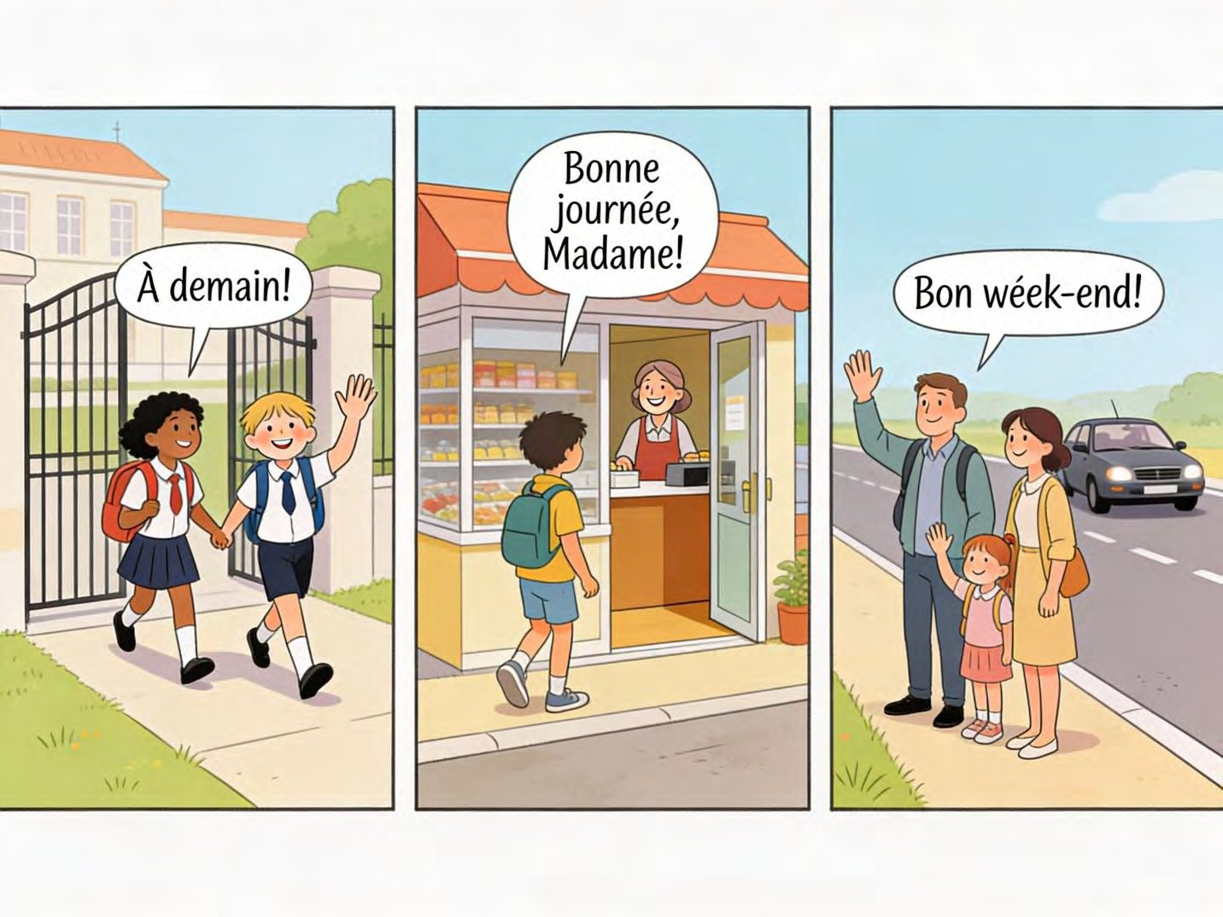

EVALUATION

- What does "À tout à l'heure" mean and when do you use it? (See you later today).
- Your teacher is leaving school at 3 PM. What polite wish can you say? (Bonne journée!).
- Translate "Have a good weekend" to French. (Bon week-end!).
- True or False: You can use "Salut" to say goodbye to your friend. (True).
- If you are saying goodbye to a friend on Thursday and you have plans to play together on Friday evening, what could you say? (À demain! or À ce soir! [for Friday]).
ASSIGNMENT

- (Written): Write the French phrase you would use to wish your friend a good day as you go home from school. (Bonne journée!).
- (Written): Write the French phrase for "See you later" (assuming you'll meet again the same day). (À tout à l'heure!).
- (Drawing & Writing): Draw a simple picture of students happily leaving school on a Friday. Write a fitting French caption for your picture. (e.g., Bon week-end!).

WEEK 9: PRENDRE CONGÉ (TAKING LEAVE) - PART 2.

OBJECTIVES By the end of the lesson, pupils should be able to:

- Express gratitude when leaving a place.
- Construct a simple dialogue combining greetings and farewells.
- Demonstrate polite behavior when taking leave.

CONTENT Expressing Gratitude (Remercier): Before you say goodbye, it is very polite to thank the person for their time, help, or hospitality.
- Merci beaucoup. (mair-see boh-koo) - Thank you very much.
- Merci pour tout. (mair-see poor too) - Thank you for everything. (Great when leaving a party or a visit).
- Merci bien. (mair-see byehn) - Thanks a lot. (Another way to say thank you).

Building a Complete, Polite Conversation: A good conversation has a clear start, middle, and end. Let's build one step-by-step.
- Greeting: Start with a polite "Bonjour" or friendly "Salut".
- Ask about well-being: Show you care by asking "Comment ça va?"
- Respond & Exchange: Answer and ask back "Et toi?" or "Et vous?".
- State your reason for leaving: You can say "Je dois partir" (I must go) or just move to the goodbye.
- Express thanks: Say "Merci" or "Merci beaucoup".
- Say goodbye: Use an appropriate phrase like "Au revoir" or "À demain".
- Wish them well: End with "Bonne journée!" etc.

Example Dialogue

- Tunde: Bonjour, Maman. (Hello, Mum.)
- Maman: Bonjour, Tunde. Ça va? (Hello, Tunde. How are you?)
- Tunde: Ça va bien, merci. Je vais jouer chez Ibrahim. (I'm fine, thank you. I'm going to play at Ibrahim's house.)
- Maman: D'accord. Sois prudent! (Okay. Be careful!)
- Tunde: Merci, Maman. Au revoir! (Thank you, Mum. Goodbye!)
- Maman: Au revoir, mon fils. À tout à l'heure! (Goodbye, my son. See you later!)

Polite Behavior: When taking leave from an adult, remember to speak clearly, make eye contact, and smile. It shows respect.
EVALUATION

- How do you say "Thank you very much" in French? (Merci beaucoup).
- What does "Merci pour tout" mean? (Thank you for everything).
- Put these parts of a conversation in the correct order: (Ça va?), (Au revoir!), (Bonjour.), (Ça va bien, merci.). (Bonjour. -> Ça va? -> Ça va bien, merci. -> Au revoir!).
- Why is it important to say thank you before leaving a friend's house? (To show appreciation and good manners).
- Complete the phrase: Merci . (beaucoup / bien / pour tout).

ASSIGNMENT

- (Writing a Dialogue): Write a short dialogue (4 lines) between two friends (A and B) who meet and then say goodbye. Include a greeting, asking "how are you?", and a farewell.
- (Translation): Translate into English: "Merci beaucoup. Au revoir." (Thank you very much. Goodbye.)
- (Oral Practice): With a family member at home, practice saying thank you and goodbye in French after they help you with something (e.g., after they give you food, help with homework).

WEEK 10: REVIEW AND INTEGRATION: IDENTITY THEME.

OBJECTIVES By the end of the lesson, pupils should be able to:

- Introduce themselves completely (Name, Age, Nationality, Gender) in a paragraph.
- Create a personal "Identity Card" in French.
- Participate in a class presentation using correct French pronunciation.

CONTENT Comprehensive Self-Introduction (Une Présentation Complète): Now, let's combine everything we have learned about ourselves into one smooth paragraph. This is your French "elevator pitch"!
Structure:

- Greeting: Bonjour!
- Name: Je m'appelle [Your Name].
- Age: J'ai [Number] ans.
- Nationality: Je suis Nigérian(e). (Remember the 'e' for girls)
- Gender: Je suis un garçon. / Je suis une fille.
- Closing: Au revoir!

Example (Boy): Bonjour! Je m'appelle Femi. J'ai neuf ans. Je suis Nigérian. Je suis un garçon. Au revoir! Example (Girl): Bonjour! Je m'appelle Zainab. J'ai dix ans. Je suis Nigériane. Je suis une fille. Au revoir!
Creating a French Identity Card (Carte d'Identité): In many countries, people carry an ID card. Let's make our own classroom version in French.
- Nom: (nohm) - This means Surname or Last Name. (e.g., Adekunle)
- Prénom: (pray-nohm) - This means First Name. (e.g., Chinedu)
- Âge: (ahzh) - Age.
- Pays: (pay-ee) - Country. (Nigeria)
- Sexe: (sex) - Gender. You can write M for Masculin (Male) or F for Féminin (Female).
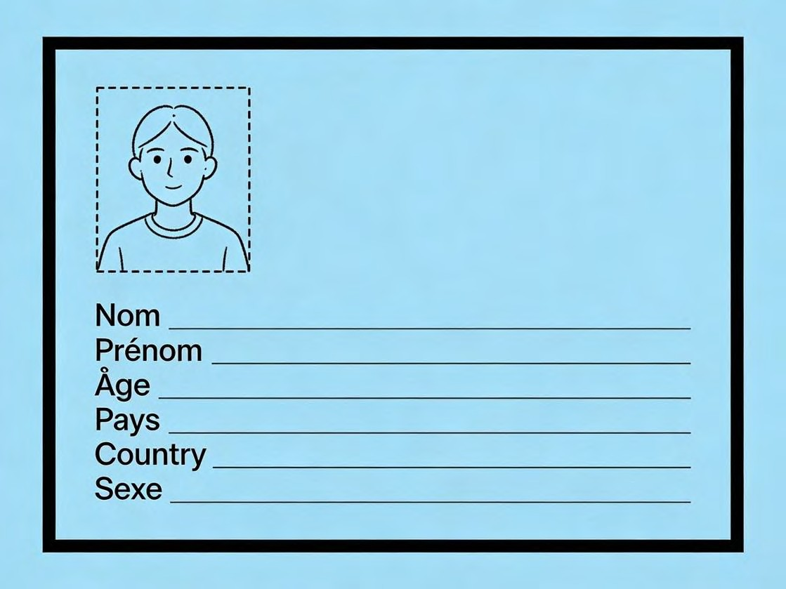

Class Presentation Tips: Speaking in front of others can be fun! Here’s how to do a great presentation:
- Stand tall and smile.
- Take a deep breath before you start.
- Speak slowly and loudly so everyone can hear you.
- Look at your classmates as you speak.
- Pronounce carefully: Practice the French 'R' (a gentle sound in the back of your throat, not a rolling Nigerian 'R') and the nasal sounds (like in "bonjour").
EVALUATION

- Present yourself! Tell the class your name, age, and nationality in French (2-3 sentences).
- On a French ID card, what does "Prénom" ask for? (Your First Name).
- What does "Nom" mean? (Surname/Last Name).
- Translate: "Je suis Nigérian et j'ai dix ans." (I am Nigerian and I am ten years old).
- What is the first word you should say in your presentation? (Bonjour!).
ASSIGNMENT

- (Design & Writing): Design and fill out your own French "Carte d'Identité" on a piece of paper. Draw a small picture of yourself in the corner. Write your details in French.
- (Creative Writing): Write a short paragraph (4-5 sentences) introducing your best friend to someone. Use: Il s'appelle... / Elle s'appelle..., Il a... ans / Elle a... ans, Il est Nigérian / Elle est Nigériane.
- (Oral Practice): Practice reading your full self-introduction paragraph (from Content section 1) aloud at home 5 times. Focus on clear pronunciation.

WEEK 11: REVISION CONTENT.
- Review of greetings (Formal vs Informal).
- Review of numbers 1-20.
- Review of introductions (Name, Age, Nationality, Gender).
- Review of polite expressions (Merci, S'il vous plaît, Pardon).
- General class exercises and oral practice.

PRIMARY 4 FRENCH LANGUAGE SCHEME OF WORK

SECOND TERM

Week | Topic | Breakdown (Subtopics)
1 | Présenter les membres de la famille proche (Presenting Close Family Members) - Part 1 | - Introduction to family vocabulary:  - La famille (family), Le père/papa (father/dad), La mère/maman (mother/mom)  - Le frère (brother), La sœur (sister)  - Introducing family: Voici mon père (This is my father), C'est ma mère (This is my mother)  - Possessive adjectives: mon (my - masculine), ma (my - feminine), mes (my - plural)  - Simple sentences about family: J'ai un  frère (I have a brother)
2 | Présenter les membres de la famille proche (Presenting Close Family Members) - Part 2 | - Extended family vocabulary:  - Le grand-père (grandfather), La grand-mère (grandmother)  - L'oncle (uncle), La tante (aunt), Le cousin/La cousine (cousin)  - Les parents (parents), Les grands-parents (grandparents)  - Talking about family members: Il s'appelle... (His name is...), Elle s'appelle... (Her name is...)  - Numbers review and counting family  members
- Drawing and presenting family trees in
French
3 | Présenter les membres de la famille proche (Presenting Close Family Members) - Part 3 | - Describing family members (basic): grand(e) (big/tall), petit(e) (small/short), jeune (young), vieux/vieille (old)  - Family relationships: Mon père et ma mère sont mes parents (My father and mother are my parents)  - Verb "avoir" (to have) - present tense: J'ai, Tu as, Il/Elle a  - Creating family descriptions: J'ai deux frères et une sœur (I have two brothers and one sister)  - Family-themed songs and rhymes
4 | Parler de l'école (Talking about School)  - Part 1 | - School vocabulary:  - L'école (school), La classe (classroom), Le/La professeur(e) (teacher)  - L'élève (student), Le tableau (board), Le bureau (desk/office)  - Le cahier (notebook), Le livre (book), Le stylo (pen), Le crayon (pencil)  - Saying where you study: Je vais à l'école (I go to school), J'étudie à... (I study at...)  - Simple school sentences: Voici mon  école (This is my school)
5 | MID-TERM EXAMINATION | - Assessment of Weeks 1-4

6 | MID-TERM BREAK | - Holiday/Rest
7 | Parler de l'école (Talking about School)  - Part 2 | - More school vocabulary:  - La bibliothèque (library), La cour de récréation (playground)  - La salle de classe (classroom), Le directeur/La directrice (headteacher)  - Les matières (subjects): français, anglais, mathématiques, sciences  - School subjects: J'aime le français (I like French), J'étudie les mathématiques (I study mathematics)  - Verb "aller" (to go) - present tense: Je  vais, Tu vas, Il/Elle va
8 | Parler de l'école (Talking about School)  - Part 3 | - School activities vocabulary:  - Étudier (to study), Lire (to read), Écrire (to write), Écouter (to listen)  - Parler (to speak), Apprendre (to learn), Jouer (to play)  - Days of the week: lundi, mardi, mercredi, jeudi, vendredi, samedi, dimanche  - School schedule: Le lundi, j'ai français (On Monday, I have French)  - Describing school day: À l'école, je lis  et j'écris (At school, I read and write)
9 | Parler de l'école (Talking about School)  - Part 4 | - School locations and directions:  - Où est...? (Where is...?), Voici/Voilà (Here is/There is)

- À côté de (next to), Devant (in front of), Derrière (behind)
- Colors in French: rouge (red), bleu(e) (blue), jaune (yellow), vert(e) (green), noir(e) (black), blanc(he) (white)
- Describing school items: Mon cahier est rouge (My notebook is red)
- Creating "Mon école" (My school)
posters and presentations
10 | Review and Integration: Immediate Environment Theme | - Comprehensive review of family and school vocabulary  - Creating family presentations in French  - School tour descriptions in French  - Role-play: introducing family members to teachers/friends  - Dialogues: talking about school experiences  - French language games: family bingo,  school vocabulary matching
11 | REVISION | - Review: Family members, school vocabulary, days of week, colors,  verbs avoir and aller
12 | EXAMINATION | - End of Term Assessment (Oral and  Written)
13 | CLOSING/VACATION | - Term ends

PRIMARY 4 FRENCH LANGUAGE LESSON NOTES SECOND TERM
WEEK 1: PRÉSENTER LES MEMBRES DE LA FAMILLE PROCHE (PRESENTING CLOSE FAMILY MEMBERS) - PART 1.
OBJECTIVES By the end of the lesson, pupils should be able to:

- List the French names for close family members (Father, Mother, Brother, Sister).
- Use the correct possessive adjectives ("mon" and "ma") to introduce family members.
- Introduce a family member using "Voici" or "C'est".
- Construct simple sentences stating family members they have.

CONTENT Introduction to Family Vocabulary (La Famille): The family is the most important group of people in our lives. In French, we call it "la famille" (lah fah-mee). Today, we learn the names of the people who live in our home.
- Le père (luh pair) / Papa - The father / Dad. Think of your dad, the head of the family.
- La mère (lah mair) / Maman - The mother / Mom. Think of your mum, who cares for everyone.
- Le frère (luh frair) - The brother. This is any boy who shares the same parents as you.
- La sœur (lah sur) - The sister. This is any girl who shares the same parents as you.

Saying "My" in French: Possessive Adjectives (Mon / Ma): In English, we say "my father" and "my mother." The word "my" doesn't change. In French, the word for "my" changes depending on whether the family member is male or female.
- Mon (mohn): This means "my" and is used before masculine words. Père and frère are masculine.
- Mon père (my father)

- Mon frère (my brother)
- Ma (mah): This means "my" and is used before feminine words. Mère and sœur are feminine.
- Ma mère (my mother)

- Ma sœur (my sister)

Memory Trick: Mon sounds a bit like "man" (for males). Ma sounds like "mama" (for females).
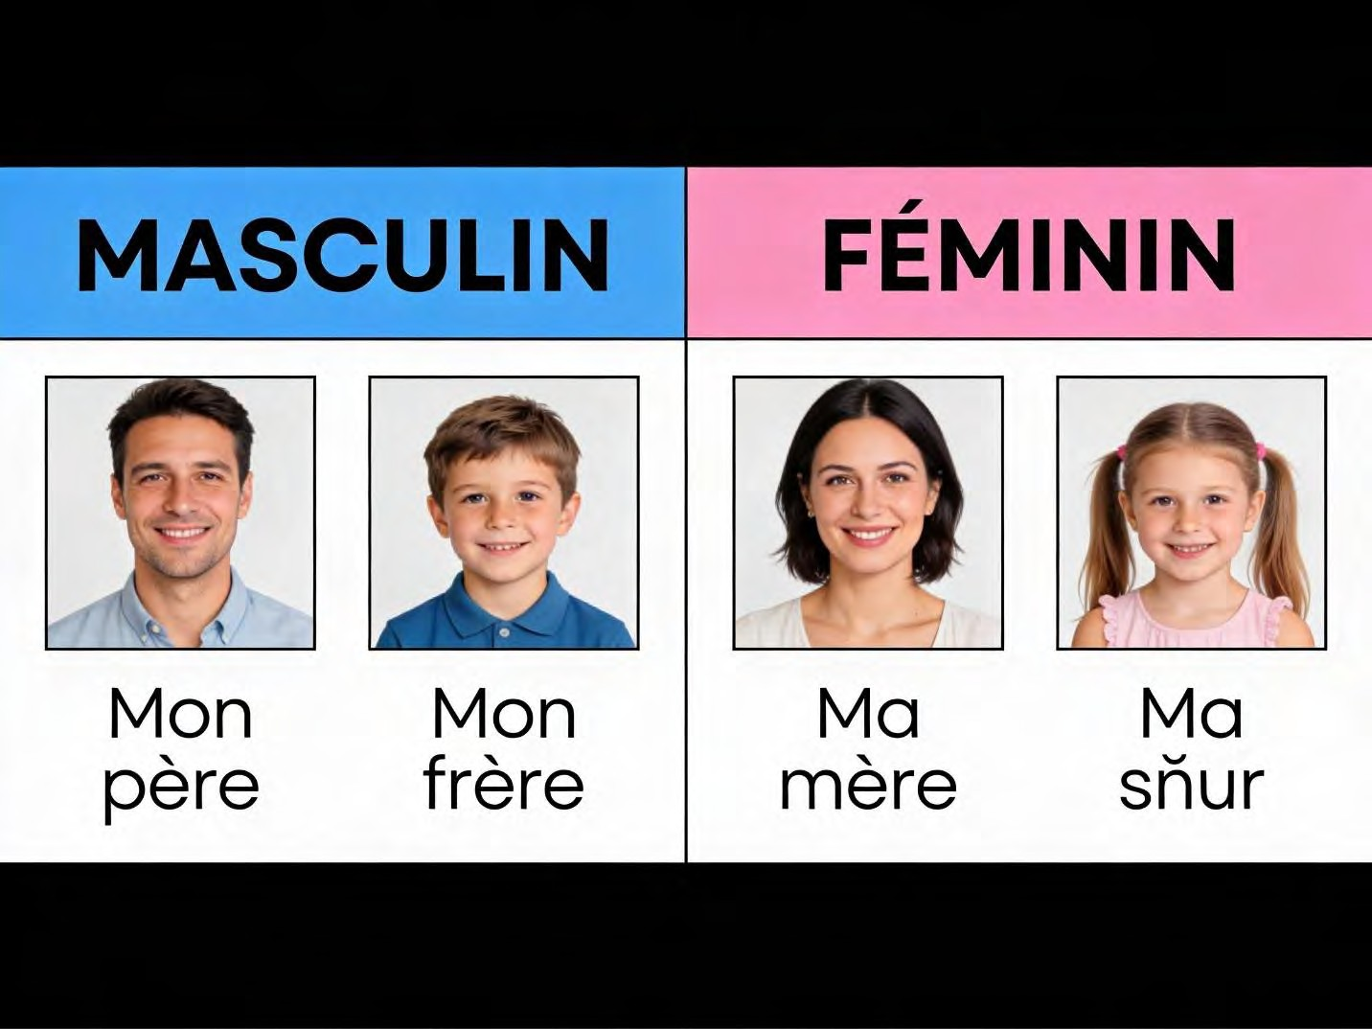

Introducing Your Family (Voici / C'est): When you want to show someone a picture or point out a family member, you use special phrases:
- Voici... (vwah-see): This means "Here is...". It's perfect when you are showing a photo or presenting someone.
- Example: Voici mon père. (Here is my father.)
- C'est... (say): This means "This is..." or "He/She is...". It's a very common and natural way to introduce someone.
- Example: C'est ma mère. (This is my mother.)

Talking About What You Have (J'ai...): To say who is in your family, you use the verb
"avoir" (to have). The form for "I have" is "J'ai" (zhay).

- J'ai un frère. (I have a brother.) - 'Un' is used for one masculine thing/person.
- J'ai une sœur. (I have a sister.) - 'Une' is used for one feminine thing/person.
- J'ai deux sœurs. (I have two sisters.) - For more than one, we don't use un/une.

EVALUATION

- What is the French word for "The Mother"? (La mère).
- Translate "Mon frère" into English. (My brother).
- Do we say "Mon mère" or "Ma mère"? Why? (Ma mère, because 'mère' is feminine).
- You are showing your friend a family photo and pointing to your dad. What French sentence do you say? (Voici mon père. / C'est mon père.)
- Translate into English: "C'est ma mère." (This is my mother.)

ASSIGNMENT

- (Drawing & Labelling): Draw a picture of your father and mother. Under your father's picture, write "Mon père". Under your mother's picture, write "Ma mère".
- (Fill-in-the-Blank): Complete the sentence with Mon or Ma: " sœur s'appelle Amina." (Ma).
- (Sentence Writing): Write one sentence in French stating whether you have a brother or a sister. (e.g., J'ai un frère. / J'ai une sœur.)

WEEK 2: PRÉSENTER LES MEMBRES DE LA FAMILLE PROCHE (PRESENTING CLOSE FAMILY MEMBERS) - PART 2.
OBJECTIVES By the end of the lesson, pupils should be able to:

- List the French names for extended family members (Grandparents, Uncle, Aunt, Cousin).
- State the names of their family members using "Il s'appelle" or "Elle s'appelle".
- Count family members using French numbers.
- Present a simple family tree verbally.

CONTENT Extended Family Vocabulary (La Famille Élargie): Our family is bigger than just our parents and siblings. We also have wonderful grandparents, aunts, uncles, and cousins.
- Les grands-parents (lay grahn-pah-rahn) - The grandparents. This is the word for grandfather and grandmother together.
- Le grand-père (luh grahn-pair) / Papi - The grandfather.
- La grand-mère (lah grahn-mair) / Mami - The grandmother.
- L'oncle (lon-kl) - The uncle.
- La tante (lah tahnt) - The aunt.
- Le cousin (luh koo-zan) - The cousin (boy).
- La cousine (lah koo-zeen) - The cousin (girl).

Saying Their Names: To tell someone the name of a family member, we use a different structure.
- For males (Il s'appelle...): This means "His name is..." or "He is called...".

- Example: Mon oncle, il s'appelle Tunde. (My uncle, his name is Tunde.)

- For females (Elle s'appelle...): This means "Her name is..." or "She is called...".

- Example: Ma tante, elle s'appelle Funke. (My aunt, her name is Funke.)

Counting Family Members (Review of Numbers): Let's use our numbers from last term to count our family! Remember "J'ai" (I have).
- J'ai un grand-père. (I have one grandfather.)
- J'ai deux tantes. (I have two aunts.)
- J'ai trois cousins. (I have three [male] cousins.)

The Family Tree (L'Arbre Généalogique): A family tree is like a drawing that shows how everyone in a family is related, from grandparents down to children. It looks like a tree with branches.
- At the top are the grands-parents.
- Below them are their children: your père, mère, oncles, and tantes.
- At the bottom are the children: you, your frères, sœurs, and cousins/cousines.
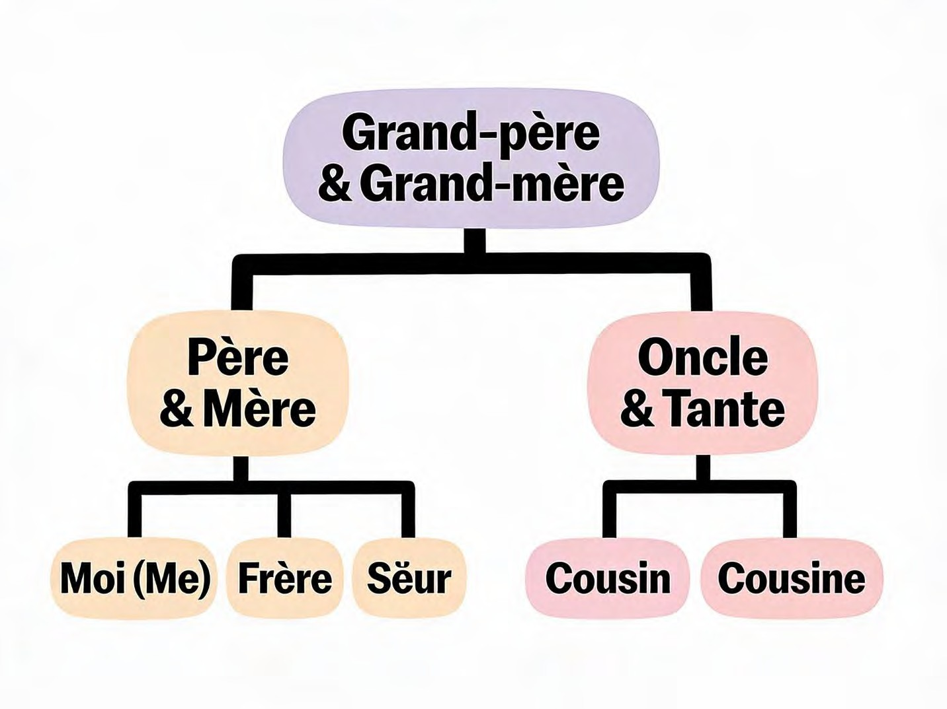

EVALUATION

- How do you say "Grandmother" in French? (La grand-mère).
- What is the French word for "Uncle"? (L'oncle).
- How would you say "Her name is Bimpe" when talking about your aunt? (Ma tante, elle s'appelle Bimpe.)
- Translate this sentence: "Mon grand-père, il s'appelle Babatunde." (My grandfather, his name is Babatunde.)
- What is the French word for a female cousin? (La cousine).

ASSIGNMENT

- (Written): Write two sentences giving the names of your grandfather and grandmother. Use: "Mon grand-père s'appelle..." and "Ma grand-mère s'appelle...".
- (Drawing Practical): Draw a simple "family tree" for yourself. Draw an apple tree shape. At the roots, draw yourself and write "Moi". On a big branch above, draw your parents and write "Mon père" and "Ma mère". On another branch, draw a grandparent and write "Mon grand-père" or "Ma grand-mère".
- (Translation): Translate "Two sisters" into French. (Deux sœurs).

WEEK 3: PRÉSENTER LES MEMBRES DE LA FAMILLE PROCHE (PRESENTING CLOSE FAMILY MEMBERS) - PART 3.
OBJECTIVES By the end of the lesson, pupils should be able to:

- Use the verb "avoir" (to have) correctly in the singular forms (J'ai, Tu as, Il a, Elle a).
- Describe family members using basic adjectives (grand, petit, jeune, vieux).
- Explain simple family relationships.
- Construct a full sentence describing their own family composition.

CONTENT The Verb "Avoir" (To Have) - More Forms: We know "J'ai" (I have). Now let's learn how to say "you have," "he has," and "she has." This is called conjugating the verb.
- J'ai (zhay) - I have.
- Tu as (too ah) - You have (informal, to a friend).
- Il a (eel ah) - He has.
- Elle a (el ah) - She has.

Examples:

- Tu as un frère? (Do you have a brother?)
- Il a une sœur. (He has a sister.)
- Elle a deux cousins. (She has two cousins.)

Describing Your Family (Les Adjectifs): We can use simple words to describe what our family members are like.
- Grand(e) (grahn/grahnd) - Big/Tall. (Add 'e' for feminine: ma sœur est grande).
- Petit(e) (puh-tee/ puh-teet) - Small/Short. (Add 'e' for feminine).
- Jeune (zhuhn) - Young.
- Vieux / Vieille (vyuh / vyeh-ee) - Old. (Vieux for masculine, Vieille for feminine).

How to use them: Place the adjective after the verb "est" (is).

- Mon père est grand. (My father is tall.)
- Ma sœur est petite. (My sister is small/short.)
- Mon grand-père est vieux. (My grandfather is old.)

Understanding Family Relationships: Let's learn how to explain who is who in the family.

- Mes parents (may pah-rahn) - My parents (father and mother together).
- Le père de mon père est mon grand-père. (The father of my father is my grandfather.) This is a logical way to think about relationships.
- La sœur de ma mère est ma tante. (The sister of my mother is my aunt.)

Creating a Full Family Description: Now, let's combine everything into a short paragraph about our family.
- Example: "Bonjour. Je m'appelle Kemi. J'ai une famille grande. J'ai un frère et une sœur. Mon frère est petit. Ma sœur est jeune. Ma mère est gentille (kind). J'aime ma famille."
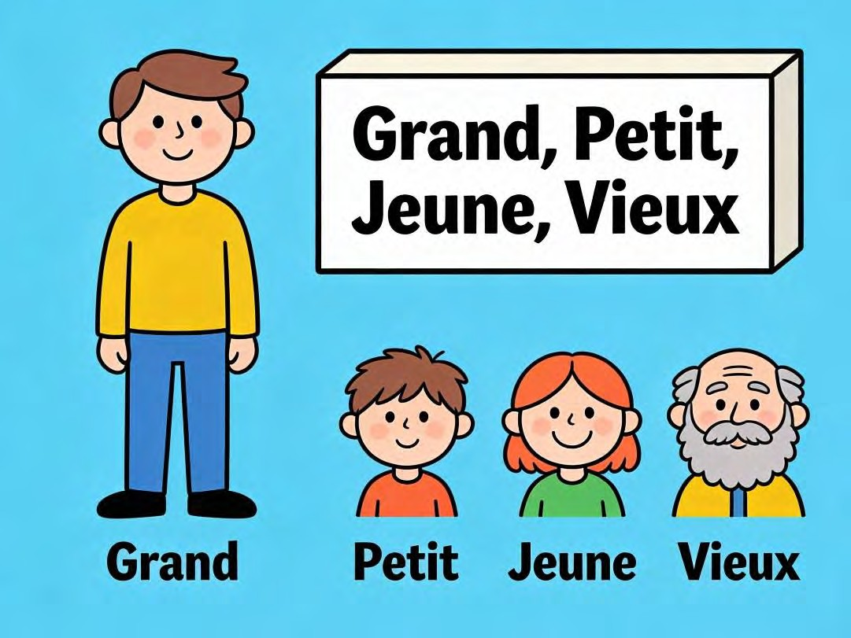

EVALUATION

- What does "J'ai" mean? (I have).
- Translate "Elle a" into English. (She has).
- What is the opposite (antonym) of "Grand" in French? (Petit).
- How do you say "My mother is tall" in French? (Ma mère est grande.)
- Fill in the blank with the correct form of avoir: "J' deux frères." (ai).

ASSIGNMENT

- (Written): Write three sentences describing your family. Use: "J'ai..." and "Il est... / Elle est..." with an adjective. (e.g., J'ai un frère. Mon frère est grand. Ma mère est jeune.)
- (Matching): Draw lines to match the French adjective to its opposite:

- Grand -> Petit

- Jeune -> Vieux

- (Written): What is the French verb form for "He has"? (Il a).

WEEK 4: PARLER DE L'ÉCOLE (TALKING ABOUT SCHOOL) - PART 1.

OBJECTIVES By the end of the lesson, pupils should be able to:

- Identify and name common school objects in French (school, classroom, pen, book, etc.).
- Name the people found in a school (teacher, student).
- State where they study using "Je vais à..." or "J'étudie à...".
- Present their school using "Voici".

CONTENT School Vocabulary (Objects & Places) - Dans la Salle de Classe: Our school is our second home! Let's learn the French names for things we see and use every day.
- L'école (lay-kol) - The school (the whole building).
- La salle de classe (lah sal duh klass) - The classroom.
- Le tableau (luh tab-loh) - The board (blackboard or whiteboard).
- Le bureau (luh byoo-roh) - The desk (teacher's desk) or an office.
- Le cahier (luh kah-yay) - The notebook or exercise book.
- Le livre (luh leev-ruh) - The book (textbook, storybook).
- Le stylo (luh stee-loh) - The pen.
- Le crayon (luh kray-on) - The pencil.

Tip: In French, all these objects have a gender (le = masculine, la = feminine). We use "le" for most of these school items.
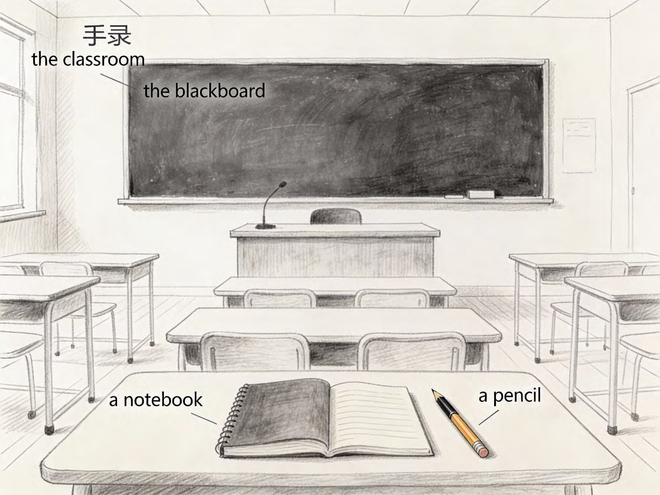

People in School (Les Personnes à l'École):

- Le professeur (luh pro-fess-ur) / La professeure (lah pro-fess-ur) - The teacher (male/female). You can also say "Monsieur" (Sir) or "Madame" (Ma'am).
- L'élève (lay-lev) - The student or pupil (boy or girl). This word is used for any learner in a school.
Talking About Your School: Now, let's learn how to talk about our own school.

- Je vais à l'école. (zhuh vay ah lay-kol) - I go to school. This is a general statement.

- J'étudie à l'école [Nom de l'école]. (zhay-too-dee ah lay-kol...) - I study at [School Name] School. This is more specific.
- Example for a Nigerian school: J'étudie à l'école primaire Ikeja. (I study at Ikeja Primary School.)
- Voici mon école. (vwah-see mohn nay-kol) - Here is my school / This is my school.
(Perfect when showing a picture).

EVALUATION

- What is the French word for "Book"? (Le livre).
- How do you say "Pen" in French? (Le stylo).
- Who is "L'élève"? (The student/pupil).
- Translate: "Voici mon école." (Here is my school / This is my school.)
- What do we call "The board" where the teacher writes in French? (Le tableau).

ASSIGNMENT

- (Drawing & Labelling): Draw three school items: a pen, a book, and a board. Under each drawing, write its French name (Le stylo, Le livre, Le tableau).
- (Sentence Completion): Complete this sentence: "Je vais à ." (l'école).
- (Written): Write a full sentence in French stating the name of your school. Use: "J'étudie à [Your School's Name]." (You can write the school name in English if you don't know the French translation).

WEEK 5: MID-TERM EXAMINATION (Assessment of topics covered in Weeks 1-4).

WEEK 6: MID-TERM BREAK (Holiday/Rest Period).

WEEK 7: PARLER DE L'ÉCOLE (TALKING ABOUT SCHOOL) - PART 2.

OBJECTIVES By the end of the lesson, pupils should be able to:

- Identify more places within the school (library, playground).
- List four school subjects in French.
- Use the verb "aller" (to go) in the singular forms (Je vais, Tu vas, Il va).
- Express preference for a subject using "J'aime".

CONTENT More Places in the School (Les Endroits): A school is not just classrooms! Let's explore other important places.
- La bibliothèque (lah bib-lee-oh-tek) - The library. A quiet place full of books!
- La cour de récréation (lah coor duh ray-cray-ah-see-on) - The playground. Where you run and play during break time!
- Le bureau du directeur - The headteacher's office.
- Les toilettes (lay twah-let) - The toilets.

School Subjects (Les Matières Scolaires): We study many different subjects. Here are their names in French:
- Le français (luh frahn-say) - French.
- L'anglais (lon-glay) - English.
- Les mathématiques (lay zaht-mah-teek) / Les maths (lay maht) - Mathematics / Maths.
- Les sciences (lay syahns) - Sciences.
- L'histoire (lees-twahr) - History.
- La géographie (lah zhay-oh-grah-fee) - Geography.

Expressing Likes (J'aime...): To say you like a subject, use the verb "aimer" (to like/love). For "I like," we say "J'aime" (zhem).
- J'aime le français. (I like French.)
- J'aime les maths. (I like maths.)
- J'étudie les sciences. (I study sciences.) - You can also use this to state what you learn.
The Verb "Aller" (To Go) - Present Tense: We use this verb to say where we are going in school.
- Je vais (zhuh vay) - I go / I am going.
- Tu vas (too vah) - You go.
- Il va / Elle va (eel vah / el vah) - He goes / She goes.

Examples:

- Je vais à la bibliothèque. (I am going to the library.)
- Tu vas à la cour? (Are you going to the playground?)
- Elle va à la salle de classe. (She is going to the classroom.)
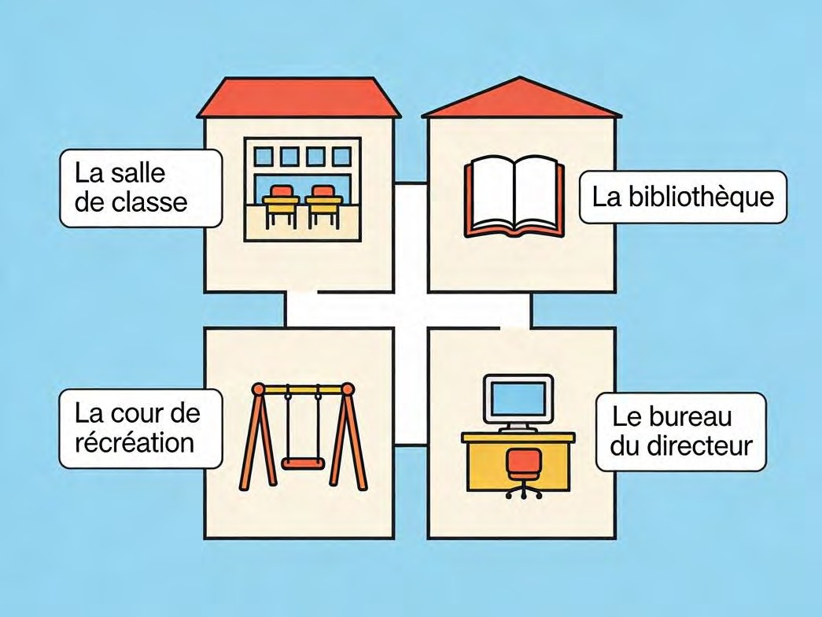

EVALUATION

- Where do you go to read storybooks quietly? Say it in French. (La bibliothèque).
- What is the French name for the subject "Mathematics"? (Les mathématiques / Les maths).
- Translate: "J'aime l'anglais." (I like English.)
- What does "Je vais" mean? (I go / I am going).
- Who works in "Le bureau du directeur"? (The headteacher/principal).

ASSIGNMENT

- (Written): Write two sentences stating subjects you like. Use: "J'aime..." (e.g., J'aime le français. J'aime les sciences.)
- (Fill-in-the-Blank): Complete the sentence with the correct form of aller: "Tu
à l'école." (vas).
- (Drawing Practical): Draw a picture of a happy playground with children playing. Label it "La cour de récréation".

WEEK 8: PARLER DE L'ÉCOLE (TALKING ABOUT SCHOOL) - PART 3.

OBJECTIVES By the end of the lesson, pupils should be able to:

- List the days of the week in French.
- Identify verbs related to school activities (read, write, listen, play).
- Describe a simple school schedule.
- Construct sentences about what they do at school.

CONTENT School Activities (Les Activités Scolaires) - Common Verbs: What do we do at school? We use action words (verbs).
- Étudier (ay-too-dyay) - To study.
- Lire (leer) - To read.
- Écrire (ay-kreer) - To write.
- Écouter (ay-koo-tay) - To listen.
- Parler (pahr-lay) - To speak.
- Jouer (zhoo-ay) - To play.
- Chanter (shahn-tay) - To sing.
- Dessiner (day-see-nay) - To draw.

Days of the Week (Les Jours de la Semaine): To talk about our schedule, we need to know the days. In French, the days are not capitalised (no big first letter).
- Lundi (luhn-dee) - Monday.
- Mardi (mahr-dee) - Tuesday.
- Mercredi (mair-kruh-dee) - Wednesday.
- Jeudi (zhuh-dee) - Thursday.
- Vendredi (vahn-druh-dee) - Friday.
- Samedi (sahm-dee) - Saturday.
- Dimanche (dee-mahnsh) - Sunday.

Remember: School days are from Lundi to Vendredi.
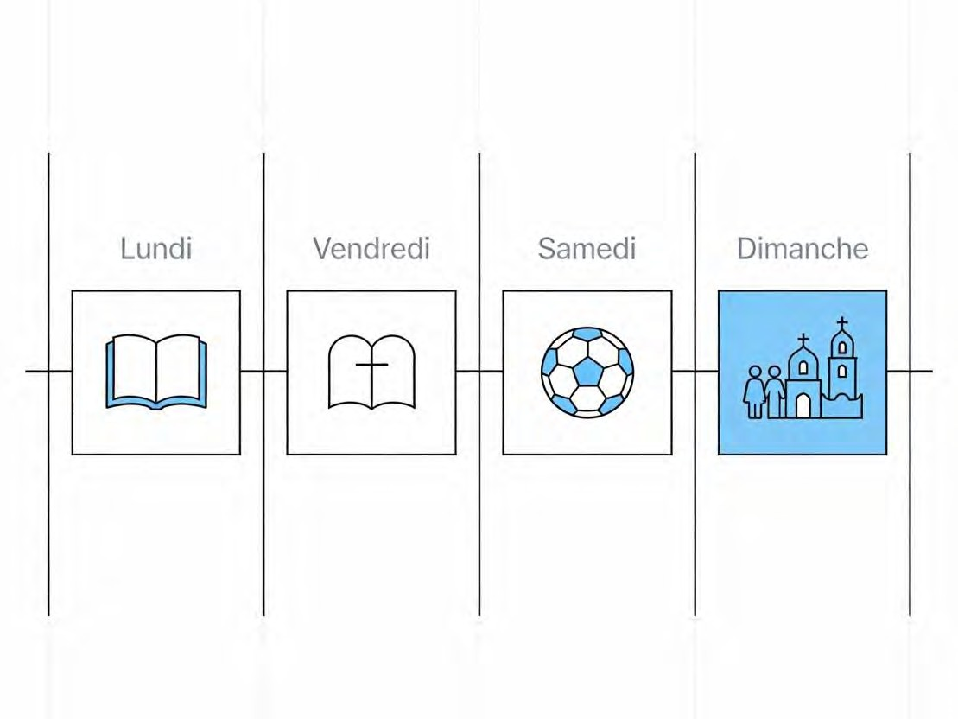

Describing Your School Day and Schedule: Let's combine days and activities to talk about what we do.
- Le lundi, j'ai français. (On Monday, I have French.)
- Le mardi, j'étudie les maths. (On Tuesday, I study maths.)
- À l'école, je lis et j'écris. (At school, I read and I write.) - Use "je" + verb (drop the -er, add -e for most: je lis, j'écris).
- Dans la cour, je joue avec mes amis. (In the playground, I play with my friends.)

EVALUATION

- Recite the days of the school week in French (Monday to Friday).
- What is the French verb for "To read"? (Lire).
- What is the French verb for "To play"? (Jouer).
- Translate this sentence: "Le mardi, j'ai anglais." (On Tuesday, I have English.)
- What do you do in the playground? Answer in a full French sentence. (Je joue dans la cour.)
ASSIGNMENT
- (Written): Write the days of the week in French from Lundi to Vendredi.
- (Translation): Translate into French: "I read and I write." (Je lis et j'écris.)
- (Sentence Completion): Complete the sentence: "Le (Monday), j'ai français." (Lundi).

WEEK 9: PARLER DE L'ÉCOLE (TALKING ABOUT SCHOOL) - PART 4.

OBJECTIVES By the end of the lesson, pupils should be able to:

- Identify six basic colors in French.
- Describe school items using colors.
- Use prepositions of place (next to, behind, in front of).
- Ask and answer "Where is...?"

CONTENT Colors (Les Couleurs): Colors make our world beautiful! They are adjectives (describing words). In French, the color usually comes after the noun (the object).
- Rouge (roozh) - Red.
- Bleu (bluh) / Bleue (bluh) - Blue. (Add 'e' for feminine nouns).
- Jaune (zhohn) - Yellow.
- Vert (vair) / Verte (vairt) - Green. (Add 'e' for feminine).
- Noir (nwahr) / Noire (nwahr) - Black.
- Blanc (blahn) / Blanche (blahnsh) - White. (Feminine form is different).

Describing School Items with Colors

- Mon cahier est rouge. (My notebook is red.)
- Le stylo est bleu. (The pen is blue.)
- Le tableau est noir. The board is black.)
- La craie est blanche. (The chalk is white.) - 'Craie' (chalk) is feminine, so we use
blanche.

Location and Directions (Où est...?): To find things in the classroom, we need words for place.

- Où est...? (oo ay) - Where is...?

- Example: Où est le livre? (Where is the book?)

- Voici / Voilà (vwah-see / vwah-lah) - Here is / There is (when you find it).

- Devant (duh-vahn) - In front of.
- Derrière (dair-ee-air) - Behind.

- À côté de (ah koh-tay duh) - Next to.

- Sur (sur) - On.

- Sous (soo) - Under.

Example Sentences:

- Le professeur est devant la classe. (The teacher is in front of the class.)
- Mon crayon est sous le bureau. (My pencil is under the desk.)
- Le livre est à côté du cahier. (The book is next to the notebook.)
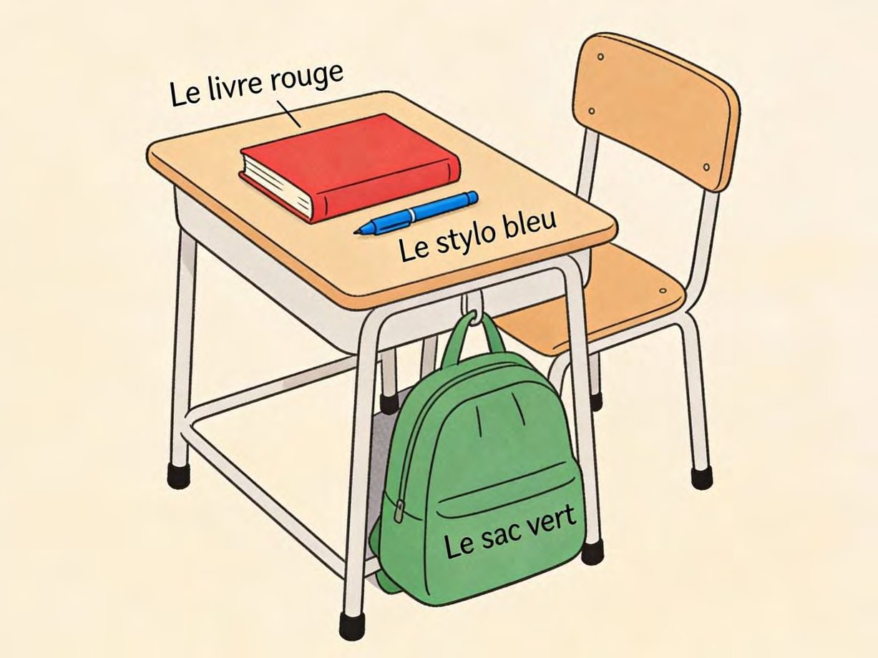

EVALUATION

- What is the French word for the color Red? (Rouge).
- What is the French word for Black? (Noir).
- Translate: "Mon stylo est vert." (My pen is green.)
- If something is "Derrière" the door, where is it? (Behind the door).
- Ask where the teacher is in French. (Où est le professeur? / Où est la professeure?).

ASSIGNMENT

- (Colouring & Writing): Colour three circles: one Red, one Blue, one Yellow. Under each circle, write its colour name in French (Rouge, Bleu, Jaune).
- (Written): Write one sentence describing the colour of your school bag. (e.g., Mon sac est noir.)
- (Drawing Practical): Draw a ball behind a box. Label the ball "le ballon" and the box "la boîte". Write a sentence describing where it is: "Le ballon est derrière la boîte."

WEEK 10: REVIEW AND INTEGRATION: IMMEDIATE ENVIRONMENT THEME.

OBJECTIVES By the end of the lesson, pupils should be able to:

- Introduce their family members in French confidently.
- Describe their school environment including places and subjects.
- Participate in a role-play introducing family to a teacher.
- Recall vocabulary for days, colors, and school objects.

CONTENT Family Review Activity: "Family Bingo" The teacher will show pictures or say words in French (père, mère, frère, sœur, grand-père, tante, etc.). Pupils have bingo cards with these words. They mark the word when they see/hear it. First to complete a line shouts "Ma famille!"
School Review Activity: "School Tour" The teacher will point to objects in the classroom or show flashcards. Pupils will stand up, point to the object, and say its name in French loudly and clearly.
- Teacher: Qu'est-ce que c'est? (What is this?)
- Pupils: C'est le tableau! C'est la porte! C'est un cahier!

Role-Play: A Parent-Teacher Meeting Scenario: It's visiting day. A pupil introduces their father to their class teacher.
- Élève (Pupil): Bonjour, Madame/Monsieur [Teacher's Name].
- Professeur (Teacher): Bonjour, [Pupil's Name].
- Élève: Voici mon père. Il s'appelle M. [Father's Surname].
- Père (Father): Enchanté, Madame. (Nice to meet you, Ma'am.)
- Professeur: Enchantée, Monsieur. (Nice to meet you, Sir.)

Oral Presentation: "Mon École et Moi" Each pupil will stand and say 3-4 sentences about their school life.
- Example Script: "Bonjour. Je m'appelle [Name]. J'étudie à [School Name]. J'aime le français et les sciences. Mon sac est bleu. Au revoir!"
EVALUATION

- What phrase do you use when introducing someone? (Voici... / C'est...).
- Name three objects you can find in a classroom. (e.g., un tableau, un cahier, un stylo).
- Name three members of your family. (e.g., mon père, ma sœur, mon grand-père).
- What day comes after "Lundi"? (Mardi).
- What colour is "Jaune"? (Yellow).

ASSIGNMENT

- (Paragraph Writing): Write a short paragraph titled "Mon École" (My School). Write 3- 4 lines. Mention your school's name, what you do there, and what you like. (e.g., "Mon école s'appelle... J'étudie le français. J'aime jouer dans la cour.")
- (Puzzle Creation): Create a simple word search puzzle for a friend. Draw a 5x5 grid and hide 5 French family words (e.g., PERE, MERE, FRERE, SOEUR, TANTE). Provide a list of the words to find.
- (Oral Practice): Practice the parent-teacher role-play dialogue at home with a family member playing the teacher or parent.

WEEK 11: REVISION
- General revision of all topics from Week 1 to Week 10.

- Focus on:

- Family vocabulary and possessive adjectives (mon, ma).

- School objects, places, and subjects.

- Days of the week (Lundi à Vendredi).

- Colors.

- Verbs "Avoir" (to have) and "Aller" (to go) in the present tense.

- Interactive games, Q&A sessions, and preparation for End of Term Examination.

PRIMARY 4 FRENCH LANGUAGE SCHEME OF WORK

THIRD TERM

Week | Topic | Breakdown (Subtopics)
1 | Compter de 0 à 20 (Counting from 0  to 20) - Part 1 | - Numbers 0-10 review and practice:  - zéro (0), un (1), deux (2), trois (3), quatre (4), cinq (5), six (6), sept (7), huit (8), neuf (9), dix (10)  - Pronunciation practice for each number  - Counting objects in classroom  - Simple math in French: deux plus trois égale cinq (2 + 3 = 5)  - Number songs and rhymes
2 | Compter de 0 à 20 (Counting from 0  to 20) - Part 2 | - Numbers 11-20:  - onze (11), douze (12), treize (13), quatorze (14), quinze (15), seize (16), dix- sept (17), dix-huit (18), dix-neuf (19), vingt (20)  - Counting from 0 to 20 fluently  - Asking "Combien?" (How many?): Combien de livres? (How many books?)  - Using numbers in context: J'ai quinze ans (I am 15 years old), Il y a dix élèves (There are 10 students)  - Number games: counting relay, number  bingo
3 | Dire l'heure (Telling Time) - Part 1 | - Introduction to time vocabulary:  - L'heure (time/hour), Quelle heure est-il? (What time is it?)  - Il est... heures (It is... o'clock)
- Telling time on the hour: Il est une heure (It's 1 o'clock), Il est deux heures (It's 2 o'clock), etc.
- Parts of the day: le matin (morning), l'après-midi (afternoon), le soir (evening), la nuit (night)
- Simple time statements: Il est huit heures
du matin (It's 8 o'clock in the morning)
4 | Dire l'heure (Telling Time) - Part 2 | - Telling time with half hours and quarters:  - Et demie (half past): Il est deux heures et demie (It's 2:30)  - Et quart (quarter past): Il est trois heures et quart (It's 3:15)  - Moins le quart (quarter to): Il est quatre heures moins le quart (It's 3:45)  - Asking and telling time in dialogues  - Daily routines with time: Je me réveille à sept heures (I wake up at 7 o'clock)  - Creating daily schedules in French
5 | MID-TERM EXAMINATION | - Assessment of Weeks 1-4
6 | MID-TERM BREAK | - Holiday/Rest
7 | Identifier les aliments et les repas (Identifying Foods and Meals) - Part 1 | - Meals vocabulary:  - Le petit-déjeuner (breakfast), Le déjeuner (lunch), Le dîner (dinner)  - Le repas (meal), Manger (to eat), Boire (to drink)  - Common foods:  - Le pain (bread), Le riz (rice), La viande (meat), Le poisson (fish)

- Les fruits (fruits): la banane (banana), l'orange (orange), la pomme (apple)
- Les légumes (vegetables): la tomate (tomato), la carotte (carrot)
- Simple sentences: Je mange du pain (I eat
bread)
8 | Identifier les aliments et les repas (Identifying Foods and Meals) - Part 2 | - More food vocabulary:  - Drinks: l'eau (water), le jus (juice), le lait (milk), le thé (tea)  - Other foods: les œufs (eggs), le fromage (cheese), le gâteau (cake)  - Nigerian foods in French: le garri, le fufu, le jollof rice  - Expressing likes and dislikes: J'aime... (I like...), Je n'aime pas... (I don't like...)  - Meal times: Je prends le petit-déjeuner à sept heures (I have breakfast at 7 o'clock)  - Food-related verbs: manger (to eat), boire  (to drink), prendre (to take/have)
9 | Identifier les aliments et les repas (Identifying Foods and Meals) - Part 3 | - At the market/restaurant vocabulary:  - Je voudrais... (I would like...), S'il vous plaît (Please)  - Combien ça coûte? (How much does it cost?), C'est combien? (How much is it?)  - Quantities: un peu de (a little), beaucoup de (a lot of), un kilo de (a kilo of)  - Table manners vocabulary: Bon appétit!  (Enjoy your meal!)

- Role-play: ordering food, buying at market
- Creating menus in French
10 | Review and Integration: Human Activities Theme | - Comprehensive review of counting, time, and food vocabulary  - Creating daily schedules with times and meals in French  - Market/restaurant role-plays  - Counting and shopping scenarios  - Food preferences presentations: Mon repas préféré (My favorite meal)  - French language games: time bingo, food matching, counting challenges  - Songs about numbers, time, and food
11 | REVISION | - Review: Numbers 0-20, telling time,  meals, food vocabulary, likes/dislikes
12 | EXAMINATION | - End of Term Assessment (Oral and  Written) - Preparation for Primary 5
13 | CLOSING/VACATION | - Term ends

PRIMARY 4 FRENCH LANGUAGE LESSON NOTES THIRD TERM
WEEK 1: COMPTER DE 0 À 20 (COUNTING FROM 0 TO 20) - PART 1.

OBJECTIVES By the end of the lesson, pupils should be able to:

- Count from 0 to 10 in French with correct pronunciation.
- Count at least five objects in the classroom using French numbers.
- Perform simple addition sums in French (e.g., 2 + 3 = 5).
- Write the French spelling for numbers 0-10.

CONTENT Numbers 0-10 (Les Nombres de Zéro à Dix): Numbers are the foundation for so many things—telling time, giving your age, and even buying things at the market. Let's start with the basics.
- 0: Zéro (zay-roh) - Like the "zero" in a football score.
- 1: Un (uh) - Sounds like the beginning of "under".
- 2: Deux (duh) - Rhymes with "duh". Lips are rounded.
- 3: Trois (twah) - Sounds like "twah". The 'r' is soft.
- 4: Quatre (kat-ruh) - Sounds like "cat" with an 'r'. The 'e' is silent.
- 5: Cinq (sank) - Sounds like "sank" a ship. The 'q' is silent.
- 6: Six (sees) - Sounds like the English word "seas".
- 7: Sept (set) - Sounds like the English word "set".
- 8: Huit (weet) - Sounds like "weet". The 'h' is silent.
- 9: Neuf (nuhf) - Sounds like "nuh" with a soft 'f' at the end.
- 10: Dix (dees) - Sounds like "dees". The 'x' sounds like 's'.

Pronunciation is Key: Let's practice as a class, using claps or stamps for each number to feel the rhythm.
Counting Real Objects (Compter les Objets): Now, let's use our numbers to count things we can see. Point to objects as you count.
- Un stylo. (One pen.)
- Deux cahiers. (Two notebooks.)
- Trois livres. (Three books.)
- Quatre élèves. (Four pupils.)
- Cinq chaises. (Five chairs.)

Activity: The teacher holds up a number of pencils. Pupils shout out the correct French number.

Simple Math in French (Les Maths Simples): In French, we use the word "plus" (ploo) for addition and "égale" (ay-gal) for equals.
- Un plus un égale deux. (1 + 1 = 2)
- Deux plus trois égale cinq. (2 + 3 = 5)
- Cinq plus quatre égale neuf. (5 + 4 = 9)

Think of it like a recipe: Two mangoes plus three more mangoes equals a bowl of five mangoes!
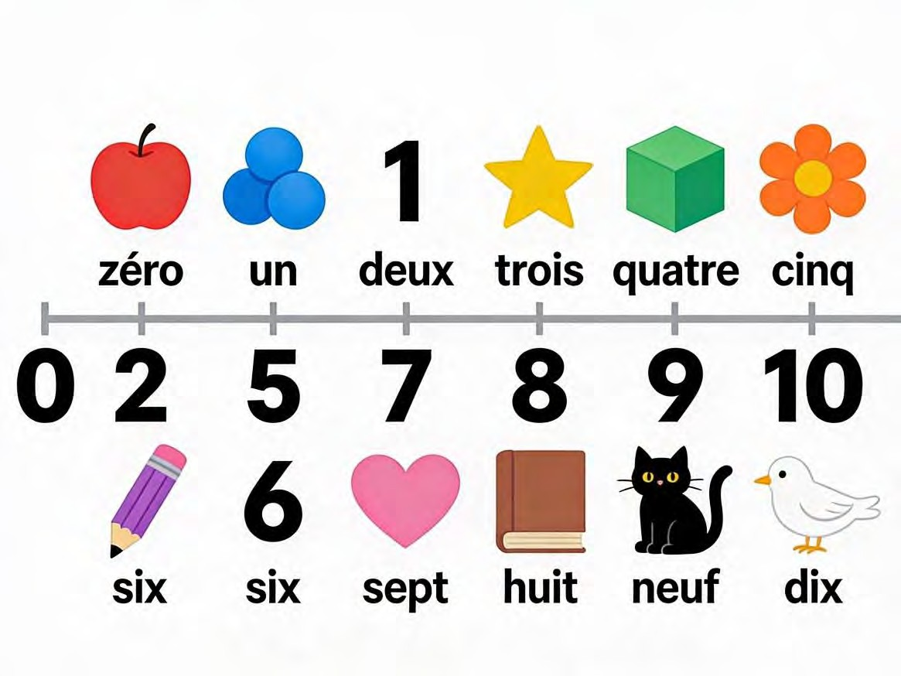

EVALUATION
- Count from un to cinq (1 to 5) out loud for the class.
- What is the French word for Seven? (Sept).
- Solve this simple sum in French words: Trois plus deux égale...? (Cinq).
- Write the French word for the number 10. (Dix).
- How do you say "Zero" in French, like when a team has no goals? (Zéro).

ASSIGNMENT

- (Written): Write the following numbers in French words: 4 ( quatre ), 8 ( huit ), 3 ( trois ), 9 ( neuf ), 0 ( zéro ).
- (Drawing & Counting): Draw six simple balls (or any object) on a paper. Underneath, write "Six ballons".
- (Math in French): Solve this and write the answer in French words: 5 + 2 = Cinq plus deux égale sept.

WEEK 2: COMPTER DE 0 À 20 (COUNTING FROM 0 TO 20) - PART 2.

OBJECTIVES By the end of the lesson, pupils should be able to:

- Count from 11 to 20 in French.
- Ask "How many?" using the phrase "Combien de...?".
- State their age using French numbers (J'ai... ans).
- Count objects up to 20.

CONTENT Numbers 11-20 (Les Nombres de Onze à Vingt): Let's continue our number journey! Notice a pattern from 17 to 19: they are like "ten-seven," "ten-eight," "ten-nine."
- 11: Onze (onz) - Sounds like "onz".
- 12: Douze (dooz) - Rhymes with "ooze".
- 13: Treize (trez) - Sounds like "trez". The 'ei' sounds like 'e' in "bed".
- 14: Quatorze (kah-torz) - Sounds like "kah-torz".
- 15: Quinze (kanz) - Sounds like "kanz".
- 16: Seize (sez) - Sounds like "says" without the 'y'.
- 17: Dix-sept (dee-set) - Literally "ten-seven."
- 18: Dix-huit (dee-zweet) - "Ten-eight." The 'x' in dix becomes a 'z' sound here.
- 19: Dix-neuf (dee-nuhf) - "Ten-nine."
- 20: Vingt (van) - Sounds like "van" with a soft 't'. The 'g' is silent.

Asking "How Many?" (Combien?): This is a very useful question for shopping, sharing, and playing games.
- Combien? (kohm-byehn) - How many? / How much?
- Combien de...? (kohm-byehn duh) - How many [things]?
- Example: Combien de livres? (How many books?)
- Answer: Cinq livres. (Five books.)
- Example: Combien de frères as-tu? (How many brothers do you have?)

Using Numbers in Real Sentences: Let's use these numbers in sentences we already know.
- Age: J'ai douze ans. (I am twelve years old.) - Remember, we use "J'ai" (I have) for age.
- Family: J'ai deux sœurs. (I have two sisters.)
- Classroom: Il y a vingt élèves dans ma classe. (There are twenty pupils in my class.) "Il y a" (eel ee ah) means "there is/are".
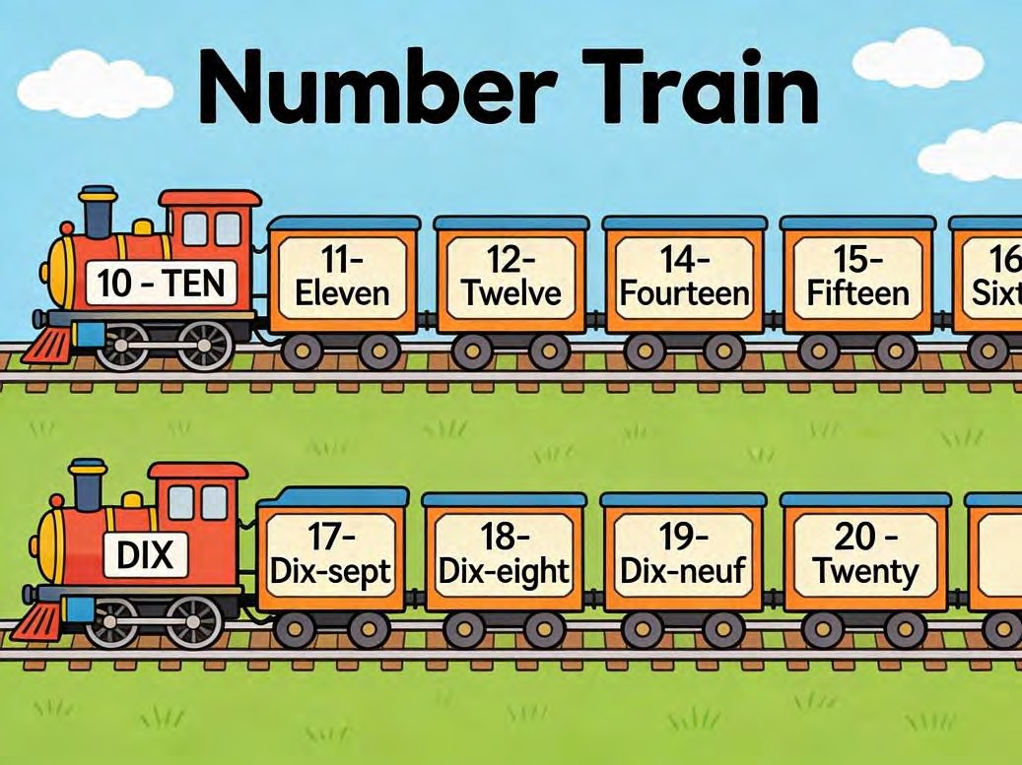

EVALUATION

- Count from dix to quinze (10 to 15) in French.
- What is the French word for Twenty? (Vingt).
- Translate this question: "Combien de stylos?" (How many pens?).
- How would you say "I am 12 years old" in French? (J'ai douze ans.).
- What number comes immediately after "Seize" (16)? (Dix-sept / 17).

ASSIGNMENT

- (Written): Write the numbers from 11 to 20 in French words (Onze, Douze... Vingt).
- (Translation): Translate this sentence into French: "I have fifteen books." (J'ai quinze livres.)
- (Answering): Answer this question in a full French sentence: Combien de doigts as-tu?
(How many fingers do you have?) J'ai dix doigts.

WEEK 3: DIRE L'HEURE (TELLING TIME) - PART 1.

OBJECTIVES By the end of the lesson, pupils should be able to:

- Ask "What time is it?" in French.
- Tell the time on the hour (1 o'clock, 2 o'clock, etc.).
- Identify the parts of the day (morning, afternoon, evening, night).
- State the time using "du matin" or "du soir".

CONTENT Asking for the Time (Demander l'Heure): Time helps us know when to go to school, eat, or play. The word for time is "l'heure" (lur).
- Question: Quelle heure est-il? (kel lur ay-teel) - What time is it? You can think of it as "Which hour is it?"
Telling Time on the Hour (L'Heure Pile): We tell time using "Il est" (eel ay) which means "It is." For times on the hour, we say the number plus "heure(s)".
- 1:00: Il est une heure. (It is one o'clock.) - Une is used because heure is feminine.
- 2:00: Il est deux heures. (It is two o'clock.) - For 2 and above, add an 's' to heure.
- 3:00: Il est trois heures.
- 10:00: Il est dix heures.
- 12:00 (Noon): Il est midi. (mee-dee)
- 12:00 (Midnight): Il est minuit. (mee-nwee)

Special Note: For 1 o'clock, we use "une heure". For all others (2, 3, 4...), we use "deux heures, trois heures...".
Parts of the Day (Les Moments de la Journée): We add these phrases to make the time more clear, especially since 6:00 could be morning or evening!
- Le matin (luh mah-tan) - The morning (from sunrise to about 12 PM).
- L'après-midi (lah-preh-mee-dee) - The afternoon (from 12 PM to about 6 PM).
- Le soir (luh swahr) - The evening (from about 6 PM to bedtime).
- La nuit (lah nwee) - The night (when it is dark and people sleep).
Putting It All Together

- Il est huit heures du matin. (It is 8 o'clock in the morning.) - Time for school!
- Il est quatre heures de l'après-midi. (It is 4 o'clock in the afternoon.) - Time for homework or play.
- Il est sept heures du soir. (It is 7 o'clock in the evening.) - Time for dinner or family time.
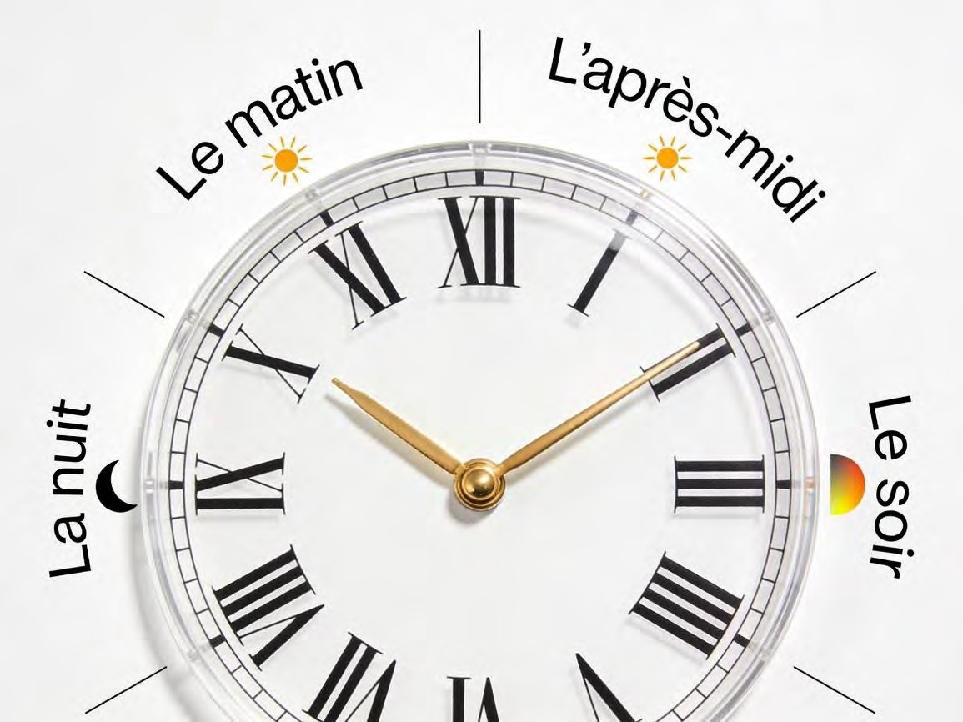

EVALUATION

- How do you ask someone for the time in French? (Quelle heure est-il?).
- How do you say "It is 4 o'clock"? (Il est quatre heures.).
- What is the French word for "Noon" (12 PM)? (Midi).
- Which part of the day is "Le matin"? (The morning).
- Translate: "Il est six heures." (It is six o'clock).

ASSIGNMENT

- (Drawing & Writing): Draw three clock faces showing: 2:00, 5:00, and 9:00. Under each clock, write the time in French (e.g., Il est deux heures.).
- (Translation): Translate into French: "It is 7 o'clock in the evening." (Il est sept heures du soir.).
- (Written): What is the French word for "Midnight"? (Minuit).

WEEK 4: DIRE L'HEURE (TELLING TIME) - PART 2.

OBJECTIVES By the end of the lesson, pupils should be able to:

- Tell time with half hours ("et demie").
- Tell time with quarter past ("et quart").
- Tell time with quarter to ("moins le quart").
- Describe a simple daily routine using time.

CONTENT Half Past, Quarter Past, and Quarter To: Now let's learn to tell time more precisely, just like we look at the minute hand on a clock.
- Half Past (30 minutes): et demie (ay duh-mee).

- Example: Il est deux heures et demie. (It is 2:30.)

- Quarter Past (15 minutes): et quart (ay kar).

- Example: Il est trois heures et quart. (It is 3:15.)

- Quarter To (45 minutes): moins le quart (mwan luh kar). This means "minus the quarter." We say the next hour, minus a quarter.
- Example: Il est quatre heures moins le quart. (It is 3:45.) Literally: "It is four o'clock minus a quarter."
Think of it like a cake: If you have a cake cut into 4 quarters, et quart means you have one piece. Moins le quart means one piece is missing from the full cake (the next hour).
Daily Routines with Time (La Routine Quotidienne): Let's talk about what we do at different times of the day. This is called our routine.
- Je me réveille à six heures. (zhuh muh ray-vay ah see zur) - I wake up at 6 o'clock.
- Je vais à l'école à sept heures et demie. - I go to school at 7:30.
- Je mange à midi. (zhuh mahnzh ah mee-dee) - I eat at noon. (Lunch)
- Je fais mes devoirs à quatre heures. (zhuh fay may duh-vwahr) - I do my homework at 4 o'clock.
- Je dîne à huit heures. (zhuh deen ah weet ur) - I have dinner at 8 o'clock.
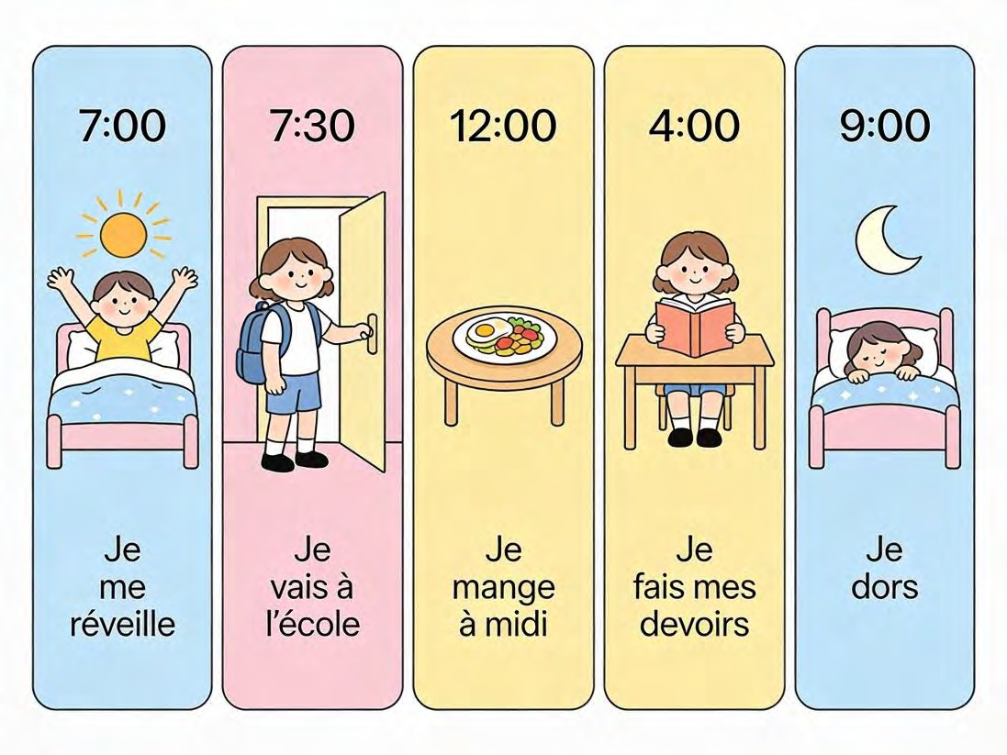

EVALUATION

- How do you say "Half past" in French? (et demie).
- What time is it if you say: "Il est cinq heures et quart"? (5:15).
- Translate into French: "It is 2:30." (Il est deux heures et demie.).
- What does the phrase "Moins le quart" mean when telling time? (Quarter to / minus a quarter).
- At what time do you go to school? Answer in a full French sentence. (Je vais à l'école à [time].).
ASSIGNMENT

- (Written): Write these times in French: a) 4:30 (Il est quatre heures et demie.) b) 8:15 (Il est huit heures et quart.) c) 6:00 (Il est six heures.)
- (Routine Sentence): Write one sentence about your own daily routine, including a time. (e.g., Je me réveille à sept heures.)
- (Drawing): Draw a clock face showing 10:30. Colour the minute hand red and the hour hand blue.

WEEK 5: MID-TERM EXAMINATION (Assessment of topics covered in Weeks 1-4).

WEEK 6: MID-TERM BREAK (Holiday/Rest Period).

WEEK 7: IDENTIFIER LES ALIMENTS ET LES REPAS (IDENTIFYING FOODS AND MEALS) - PART 1.
OBJECTIVES By the end of the lesson, pupils should be able to:

- Name the three main meals of the day in French.
- List at least five common food items (bread, rice, meat, etc.).
- Identify common fruits and vegetables in French.
- Construct simple sentences using "Je mange..." (I eat...).

CONTENT Meals of the Day (Les Repas): We eat at different times to give our bodies energy. The names of meals in French are different from English.
- Le petit-déjeuner (luh puh-tee day-zhuh-nay) - Breakfast. Literally "the little lunch." This is the first meal.
- Le déjeuner (luh day-zhuh-nay) - Lunch. The main meal in the middle of the day.
- Le dîner (luh dee-nay) - Dinner. The evening meal.
- Manger (mahn-zhay) - To eat.
- Boire (bwahr) - To drink.

Common Foods (Les Aliments Courants): These are foods you probably know and eat often.

- Le pain (luh pan) - Bread.
- Le riz (luh ree) - Rice. (A staple in Nigeria!)
- La viande (lah vee-ahnd) - Meat.
- Le poisson (luh pwah-sohn) - Fish.
- L'œuf (luhf) - Egg. (One egg). Les œufs (lay zuh) - Eggs.

Fruits and Vegetables (Les Fruits et Les Légumes): Eating fruits and vegetables keeps us healthy. Many names are similar to English!
- Fruits: La banane (banana), L'orange (orange), La pomme (pom - apple), La mangue
(mahng - mango).
- Vegetables: La tomate (tomato), La carotte (kah-rot - carrot), Les épinards (lay zay-pee- nar - spinach), L'oignon (loh-nyon - onion).
Saying What You Eat (Je mange...): To say you eat something, use "Je mange" (zhuh mahnzh)
+ the food.

- Je mange du pain. (I eat bread.) 'Du' is used for masculine foods (like pain, riz).
- Je mange de la viande. (I eat meat.) 'De la' is used for feminine foods (like viande).
- Je mange une pomme. (I eat an apple.) 'Une' for one feminine item.
- Je mange un œuf. (I eat an egg.) 'Un' for one masculine item.
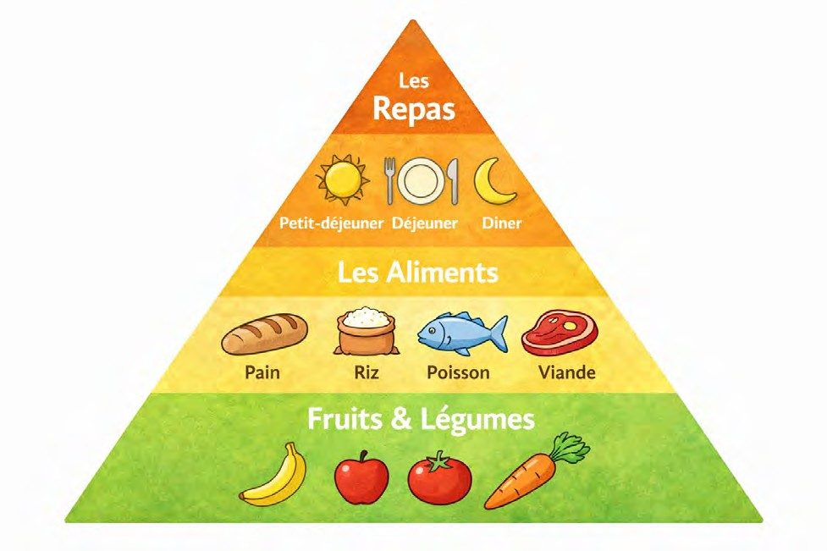

EVALUATION

- What is the French word for "Lunch"? (Le déjeuner).
- Translate "Le poisson" into English. (The fish).
- What is a common red fruit we call "La pomme" in French? (Apple).
- How do you say "I eat bread" in French? (Je mange du pain.).
- Name one vegetable from today's lesson. (e.g., La tomate, La carotte).

ASSIGNMENT

- (Drawing & Labelling): Draw and label three items: a banana, an apple, and a carrot. Write their names in French underneath (La banane, La pomme, La carotte).
- (Translation): Translate this sentence: "Je mange le petit-déjeuner." (I eat breakfast.).
- (Written List): Make a list of three foods you like to eat. Write their names in French.

WEEK 8: IDENTIFIER LES ALIMENTS ET LES REPAS (IDENTIFYING FOODS AND MEALS) - PART 2.
OBJECTIVES By the end of the lesson, pupils should be able to:

- Identify common drinks in French (water, milk, juice).
- Name Nigerian foods in French context (garri, fufu).
- Express likes and dislikes regarding food.
- State the time they have specific meals.

CONTENT

Drinks (Les Boissons): We don't just eat, we also drink! Here are some common drinks.

- L'eau (loh) - Water. (Feminine: de l'eau).
- Le lait (luh lay) - Milk.
- Le jus (luh zhoo) - Juice. Le jus d'orange (orange juice).
- Le thé (luh tay) - Tea.
- To drink is "boire" (bwahr). Je bois de l'eau. (I drink water.)

Nigerian Foods in French: We can talk about our delicious Nigerian foods in French too! We often keep the local name but use French articles (le, la, du, de la).
- Le garri.
- Le fufu.
- Le riz jollof. (Jollof rice)
- La soupe d'egusi. (Egusi soup)
- L'amala.
- Le poulet (luh poo-lay) - Chicken.

Expressing Likes and Dislikes: It's okay to have preferences! Here's how to share them politely.

- J'aime... (zhem) - I like...

- J'aime le riz. (I like rice.)
- J'aime le jus d'orange. (I like orange juice.)

- Je n'aime pas... (zhuh nem pah) - I don't like...

- Je n'aime pas le thé. (I don't like tea.)

- Je n'aime pas les épinards. (I don't like spinach.)

- J'adore... (zhah-dor) - I love... (Stronger than J'aime).

Talking About Meal Times: Let's combine time and food!

- Je prends le petit-déjeuner à sept heures. (I have breakfast at 7 o'clock.) Prendre means "to take" and is often used for meals.
- Je déjeune à une heure. (I have lunch at 1 o'clock.)
- Je dîne à huit heures du soir. (I have dinner at 8 in the evening.)

EVALUATION

- What is the most important drink for our health? Say it in French. (L'eau - Water).
- Translate this sentence: "Je n'aime pas le lait." (I don't like milk.).
- What is the French word for "Eggs"? (Les œufs).
- How do you say "I like rice" in French? (J'aime le riz.).
- Ask your friend what time they have lunch. (Tu déjeunes à quelle heure?).

ASSIGNMENT

- (Written Preferences): Write two sentences: one about a food you like, and one about a food you don't like. (e.g., J'aime le poulet. Je n'aime pas le poisson.).
- (Translation): Translate into French: "I drink water." (Je bois de l'eau.).
- (Drawing): Draw a bottle of milk and a glass of juice. Label them in French (Le lait, Le jus).

WEEK 9: IDENTIFIER LES ALIMENTS ET LES REPAS (IDENTIFYING FOODS AND MEALS) - PART 3.
OBJECTIVES By the end of the lesson, pupils should be able to:

- Use polite expressions to order food ("Je voudrais...").
- Ask for the price of an item ("Combien ça coûte?").
- Use quantity words (a little, a lot).
- Say "Enjoy your meal" in French.

CONTENT

Ordering Food Politely (Commander de la Nourriture): Imagine you are in a French café or a market. How do you ask for what you want?
- Polite Request: Je voudrais... (zhuh voo-dray) - I would like... This is much more polite than "Je veux" (I want).
- Always add: ...s'il vous plaît. (seel voo pleh) - ...please.
- Example: Je voudrais un jus d'orange, s'il vous plaît. (I would like an orange juice, please.)
- Example: Je voudrais du pain, s'il vous plaît.

Asking the Price (Demander le Prix): Before you buy, you need to know how much it costs.

- Combien ça coûte? (kohm-byehn sah koot?) - How much does it cost?
- C'est combien? (say kohm-byehn?) - How much is it? (More informal)
- The seller might answer: "C'est cent nairas." (It is 100 naira.) or "Dix nairas." (10 naira.)

Talking About Quantities: Sometimes you want a lot, sometimes just a little.

- Un peu de... (uh puh duh) - A little bit of...

- Je voudrais un peu de sucre. (I would like a little sugar.)

- Beaucoup de... (boh-koo duh) - A lot of...
- Je voudrais beaucoup de riz. (I would like a lot of rice.)

- Un kilo de... (uh kee-loh duh) - A kilo of...

Good Manners at the Table: In French culture, it is very important to wish people a good meal.

- Before eating: Bon appétit! (bohn ah-pay-tee) - Enjoy your meal! Say this to everyone at the table.
- After eating: C'était délicieux! (say-tay day-lee-syuh) - It was delicious! A nice compliment to the cook.
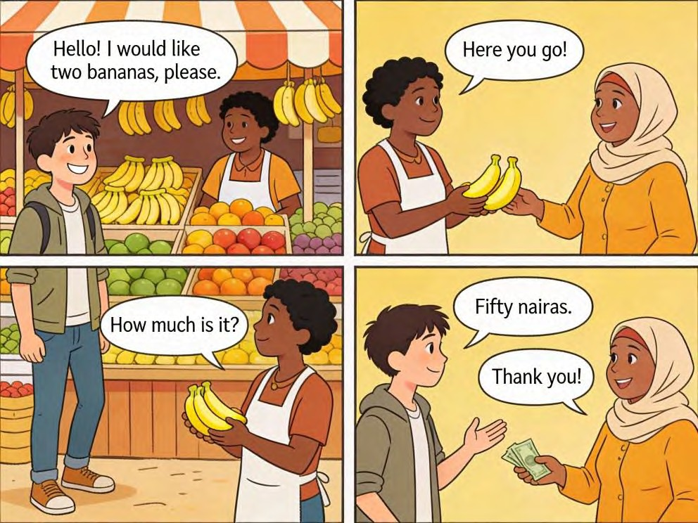

EVALUATION

- What is the polite way to ask for a piece of bread? (Je voudrais du pain, s'il vous plaît.).
- What does the question "Combien ça coûte?" mean? (How much does it cost?).
- What do you say to your family before they start eating their food? (Bon appétit!).
- How do you say "A lot of rice" in French? (Beaucoup de riz).
- Role-play: You are at a stall. Ask the teacher (the seller) for one apple. (Je voudrais une pomme, s'il vous plaît.).
ASSIGNMENT
- (Dialogue Writing): Write a short dialogue between a buyer (A) and a seller (B) at a market. Include a greeting, an order, and asking the price. (e.g., A: Bonjour! B: Bonjour! A: Je voudrais...)
- (Written): What is the French phrase for "A little bit of"? (Un peu de).
- (Oral Practice): At home tonight, before you eat dinner, try saying "Bon appétit!" to your family. Write down how they reacted.

WEEK 10: REVIEW AND INTEGRATION: HUMAN ACTIVITIES THEME.

OBJECTIVES By the end of the lesson, pupils should be able to:

- Create a daily schedule including times and meals.
- Participate in a market role-play involving counting money (numbers) and buying food.
- Present their favorite meal to the class.
- Recall vocabulary for time, numbers, and food.

CONTENT My Daily Schedule (Mon Emploi du Temps): Let's create a poster of your perfect day, using French time and activities.
- 7:00 - Je me réveille. (I wake up.)
- 7:30 - Je prends le petit-déjeuner. (I have breakfast.) Je mange du pain et je bois du lait.
- 8:00 - Je vais à l'école. (I go to school.)
- 13:00 - Je déjeune. (I have lunch.) Je mange du riz et du poulet.
- 16:00 - Je joue au football. (I play football.)
- 20:00 - Je dîne avec ma famille. (I have dinner with my family.)
- 21:00 - Je dors. (I sleep.)

Market Role-Play (Jeu de Rôle: Au Marché): Let's set up a pretend market in class! Some pupils are sellers, some are buyers.
- Seller: Bonjour! Des pommes, des bananes? (Hello! Apples, bananas?)
- Buyer: Bonjour. Je voudrais deux bananes, s'il vous plaît. (Hello. I would like two bananas, please.)
- Seller: Voilà! (Here you are!)
- Buyer: C'est combien? (How much is it?)
- Seller: C'est cinquante nairas. (It is 50 naira.)
- Buyer: Merci. Au revoir! (Thank you. Goodbye!)
- Seller: Au revoir! (Goodbye!)
Presentation: My Favorite Meal (Mon Repas Préféré): Each pupil will prepare a short talk about their favorite meal.
- Example Script: "Bonjour. Mon repas préféré est le riz jollof et le poulet. J'aime aussi la banane. Je bois de l'eau. Je mange ce repas à midi avec ma famille. C'est délicieux! Merci."
EVALUATION

- What time do you usually wake up? Say it in French. (Je me réveille à [time] heures.).
- What is your favorite food? Answer in a French sentence. (Mon repas préféré est... / J'aime...).
- How do you say "20 Naira" in French? (Vingt nairas).
- Translate this market request: "Je voudrais deux pommes." (I would like two apples.).
- What question do you ask to find out the price? (Combien ça coûte? / C'est combien?).

ASSIGNMENT

- (Creative Design): Create a simple menu for a "Café Français". List at least 3 foods and
2 drinks. Write their names in French and give them a price in Naira (use French numbers, e.g., Cent nairas).
- (Schedule Writing): Write your schedule for Saturday (Samedi). Include 3 activities with their times in French. (e.g., Samedi: 9h - Je regarde la télé. 12h - Je mange...).
- (Drawing & Labelling): Draw a picture of your favourite meal on a plate. Label all the different foods and drinks in your drawing using French words.

WEEK 11: REVISION CONTENT.
- General revision of all topics from Week 1 to Week 10.

- Focus on:

- Numbers 0-20.

- Telling Time (on the hour, et demie, et quart, moins le quart).

- Meals (petit-déjeuner, déjeuner, dîner).

- Food items, Drinks, and Nigerian foods.

- Ordering food and asking prices (Je voudrais..., Combien ça coûte?).

- Interactive games, practice dialogues, and preparation for the End of Term Examination.
GET ACCESS TO MORE EDUCATIONAL RESOURCES - CLICK HERE

EDUCATIONAL RESOURCES ARCHIVE (ERA)
Get access to unlimited Educational Resources – CLICK HERE (for Primary and Secondary Schools)
- Scheme of Works
Word
PDF
PowerPoint
Excel
Flashcards
Posters
Charts
- Lesson Notes
- Educational Software
- School Management Software
- School Administrative Packages
- E-Textbooks and E-Videos
- Exam Question Bank
- MOCK Exam Questions
- School Teaching and Learning Utilities
- Common Entrance Questions
- JAMB-UTME Past Questions
- WAEC Past Questions
- E-Learning Materials
- Teaching and Learning Utilities
- Teaching and Learning Aids
…and more
CLICK HERE TO LEARN MORE

